
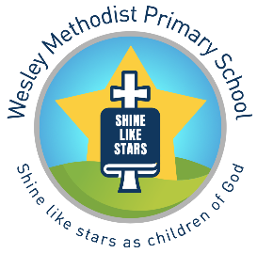

Artists, Sculptors, Designers and Architects

Year Group | Autumn | Spring | Summer | Additional Art Opportunities
Reception | Drawing | Painting | Sculpture | Christmas Art- Textiles  (Autumn Term)  Art Day – Local Artist Drawing Unit (Spring1)
Key Stage 1  Cycle A (2021-22) | Drawing  Self portraits - Giuseppe Arcimboldo | Printing  Colour Creations - Kandinksy | Sculpture  Andy Goldsworthy/ Earth Art
Cycle B (2022-23) | Drawing – Observational  Georgia O’Keefe | Painting  Henri Rousseau | Collage  Seaside Vincent Van Gogh
Lower Key Stage 2  Cycle A (2021-22) | Drawing  Warhol and the Pop Art Movement | Printing  Indian Art – History and Styles | Collage  Megan Coyle or Fred Tomaselli.
Cycle B (2022-23) | Drawing  Famous Buildings  Christopher Wren | Painting  Seurat and Pointillism | Sculpture and Digital Art  Antoni Gaudi  Modroc/ Plaster of Paris
Year 5 | Drawing  Leonardo De Vinci | Printing  Banksy | Mixed Media – Sculpture, painting,  Cityscapes  Charles Fazzino
Year 6 | Drawing  Art Illusions - Escher. | Painting  Monet and the Impressionists | Digital Art and Textiles  Famous Fashions  Meha Hindocha

