**PE**

Invasion Games – (Outdoor weather permitting) Hockey and Football

Keep-Fit and Multi-Skills games

**History**

Enter the Stone Age

During this topic, children will explain why the period is called the ‘Stone Age’. They will recognise the long period of time of the Stone Age and where it fits within the wider historical

Context. They will explore the three periods of the Stone Age: the Palaeolithic, Mesolithic and Neolithic period.

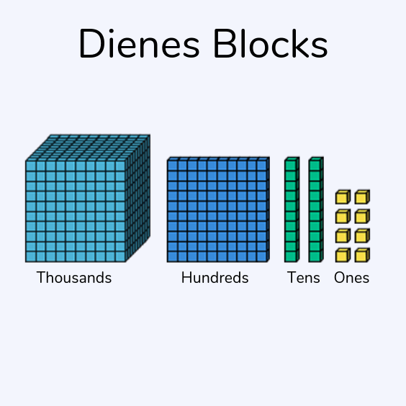



**Music**

Singing Senwa Dedende – sing in a round. Four White Horses – sing a clapping song and perform rhythms. Juba – enhance musical expression through actions and lyrics. Plynie Statek – Call and response song adding a rhythmic accompaniment.

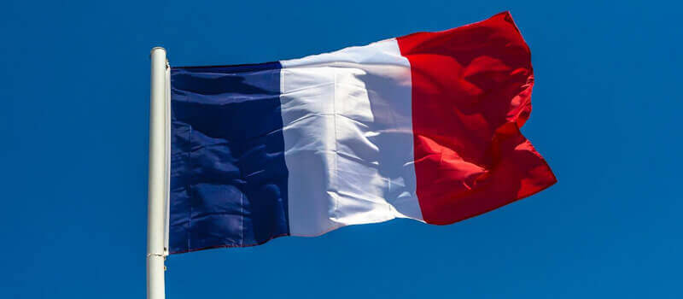

**RE**

*Judaism*

Key Question –How special is the relationship Jews have with God.

Creating Class Charters.

The Covenant Story. Jewish Affirmation.

**MFL**

French – Moi

Greetings and Introductions

Age and Numbers

Colours and Calendars/Birthdays

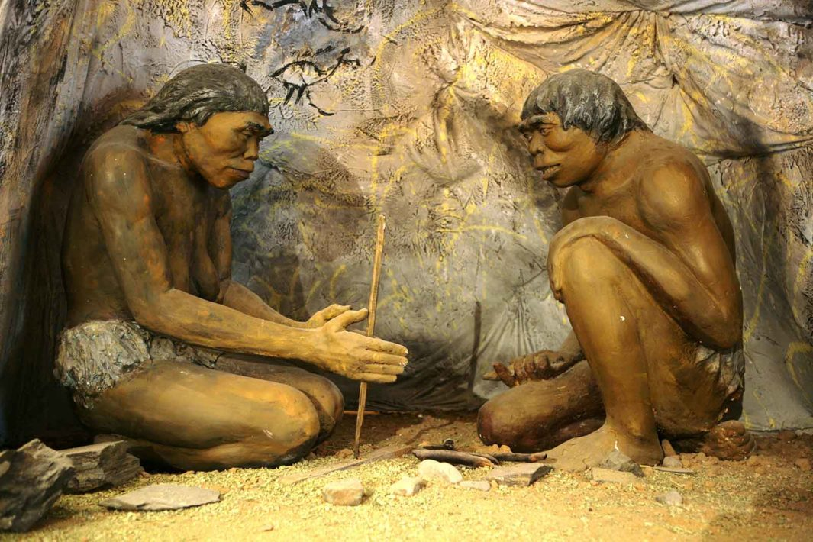

**Computing**

In computing the children will be learning all about E-safety.



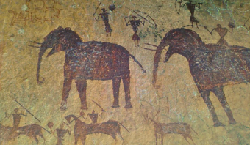

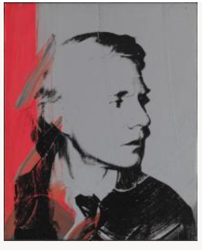

**Art**

In art, the children will be learning about Andy Warhol and his self-portraits. The children will also be learning about cave paintings and how to make paints.

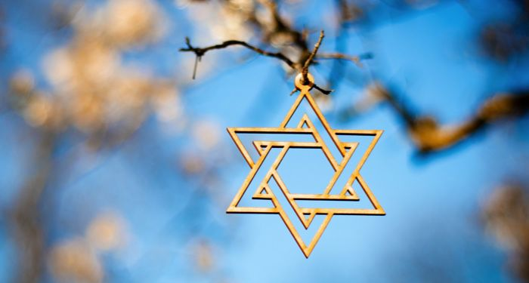

**Science**

Rocks and Soils

This will link with our History topic on The Stone Age.

Recognising and Classifying types of rocks.

Soil formation and permeability.

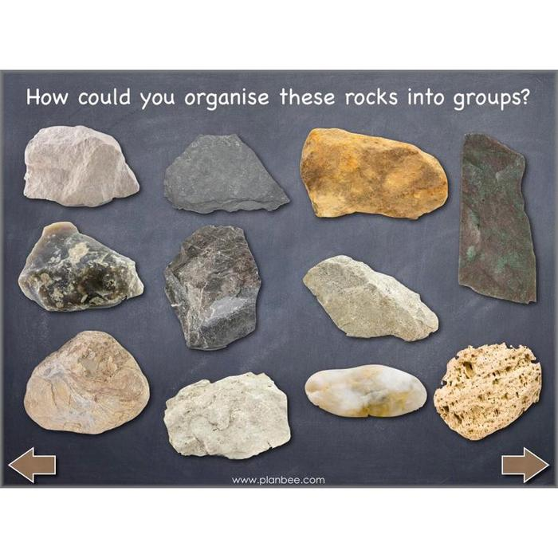

**PSHE**

**Being Me In My World**

Getting to know each other.

Our dream and nightmare schools.

Rewards and Consequences.

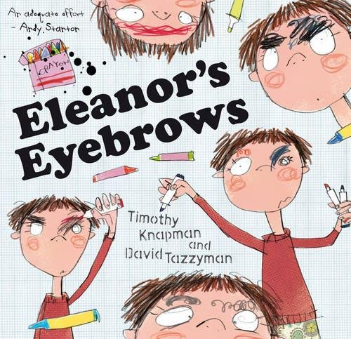

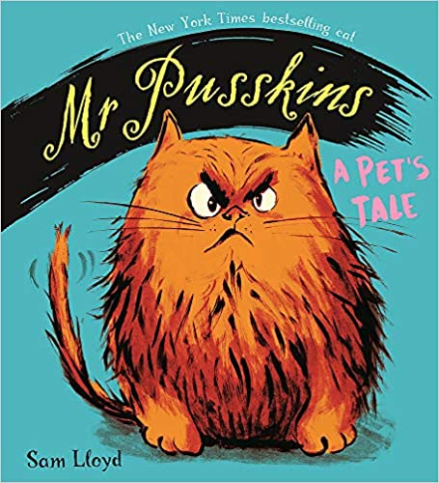

**English**

**Texts**

Mr Pusskins – Sam Lloyd

Eleanor’s Eyebrows – Timothy Knapman

**Genres**

Narrative

Diary Entry

Recount

Instructions

**Maths**

Year 3

Number – Place Value

Addition and Subtraction

Multiplication and Division

This term the children will be building on place value understanding and continue to develop their knowledge of addition and subtraction and be exposed to a number of word problems.