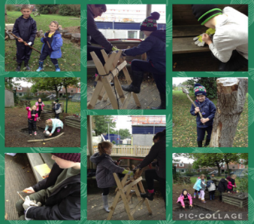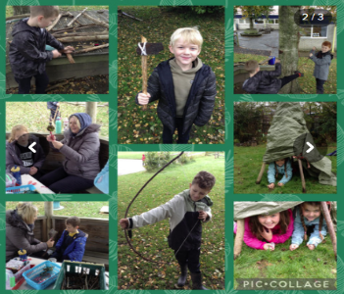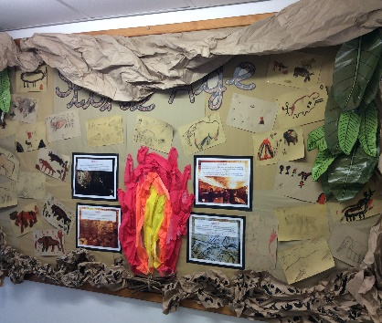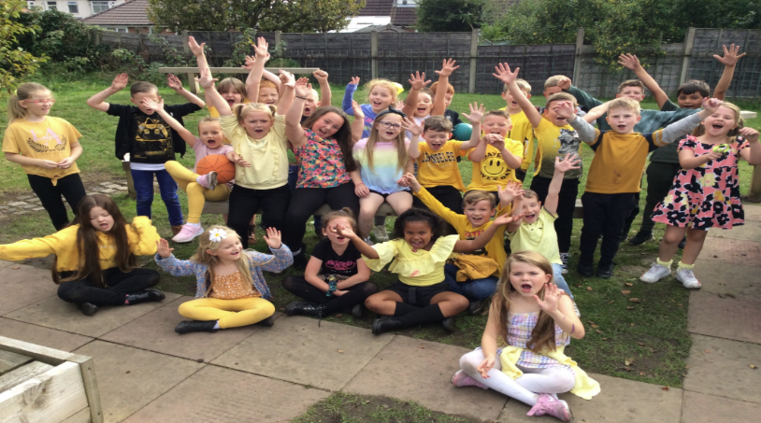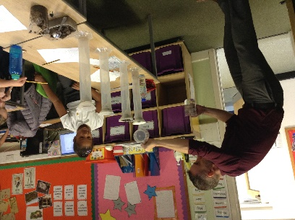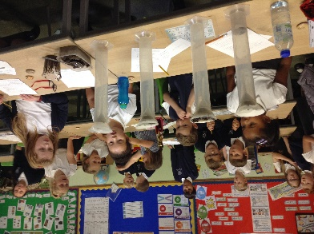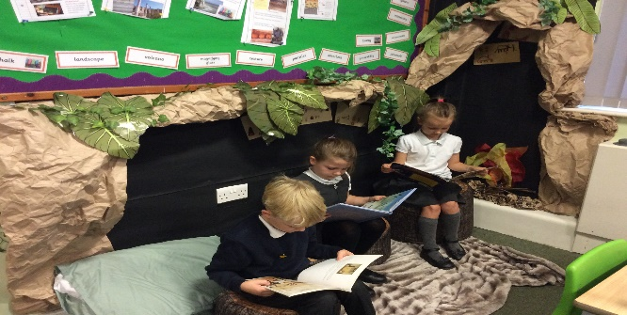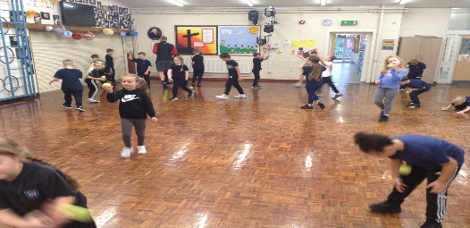

**Autumn Highlights**

**Year 3 Garvey**

What a super first half term it has been in Year 3 Garvey!

The children have all settled brilliantly into our new class and have worked really hard. Both myself and Mrs Murray are really proud of the effort they have all put in and their fantastic behaviour. We even got a new reading area!

In English we have read and worked on Mr Pusskins and Eleanor’s Eyebrows. The children have written diary entries, instructions and produced some super Missing Cat posters.

There has been lots of Art this half term, which has been great fun. We have made Stone Age cave paintings on sandpaper and looked at the artists Andy Warhol and Pablo Picasso.

Our Science topic has been Rocks and Soils. We have done lots of research and conducted some very scientific investigations.

Another exciting thing that happened this half term was that we all got to take part in Forest School. Even myself and Mrs Murray.

We have worked really hard on Addition and Subtraction in Maths and we are trying to become more confident in our Timestables. This will be continuing next half term, so please keep practising at home.

We really enjoyed PE this half term. We did lots of work on throwing and catching and even managed to play some Basketball outside when it wasn’t raining!

Thank You for all your support.

Have a Great Half Term!