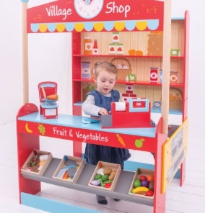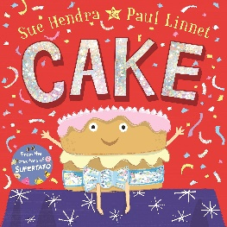

**Computing**

**Technology:**

Beebots

To explore/play with Beebots switching on/off understanding buttons through guided play.

To plan a journey of less than 5 commands (Adult supported)



**Art**

**Painting:** Experimenting with and using primary colours

Understand that when colours are mixed, new colours are created

**DT**

Structures – building a model in the environment. Explore different materials freely, to develop their ideas about how to use them and what to make. Join different materials and explore different textures.

**Science**

**Leaf Man** – Lois Ehlert  
Are all leaves the same? Exploring different leaves around school. We will use them to make a friend for Leaf Man

**Santa is coming to Manchester** – Steve Smallman  
It’s always raining in Manchester! Can you find the best material to cover Santa’s sacks with so all the presents?

**stay dry?**

**PE  
GoForIt PE Sessions**

1) Can find their own space.

2) Can travel in a variety of ways.

Co-ordination and Footwork.

Dynamic Balances. Jumping and Landing.

**PSHE**

**Jigsaw:**Celebrating Difference

**Working on:**

Turn taking Listening to others

Using positive words

**Music**

Learn to sing songs with increased control.

Building on the skills learnt in Autumn 1, children work towards a singing performance at Christmas.

**RE** Methodism and John Wesley

The Christmas Story

Christmas Traditions

**History**

Guy Fawkes and Bonfire Night Traditions

Remembrance

Look at Me Now – our journeys from birth to now

**Geography**

Diwali – celebration traditions/culture

Christmas traditions around the world – linked to similarities and difference



**Maths**

Change within 5

Number bonds to 5

Positional Language

Introducing money

Numbers to 5 problem solving

**English**

**Texts**

Cake

Snowbear

**Genres**

Narrative

Recount