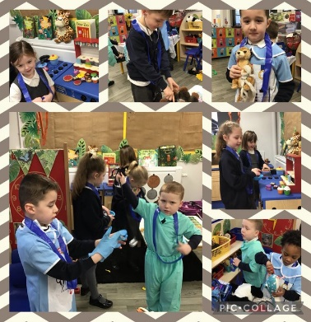
Spring 1 Reception Highlights
This half term Reception have been very busy moving forward with their reading, writing and maths work. In literacy we ventured into the jungle with our Rumble in the Jungle and Gorillas love Vanilla books. In maths we had lots of fun in the WWF themed café that was created to support our Safari Rescue Centre role play. We have also been learning about the numbers six to ten and have started recording addition calculations.
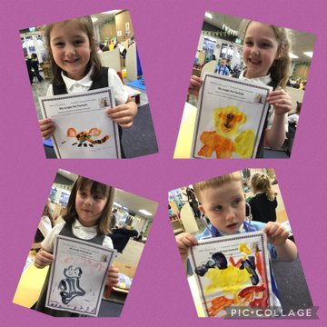
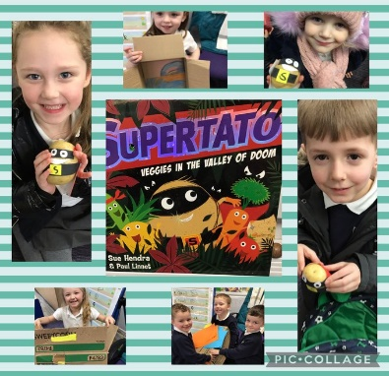
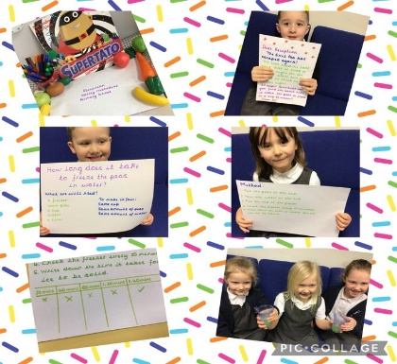
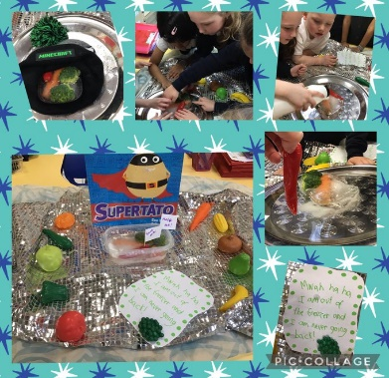
Supertato has been the theme for our science this half term and the children have enjoyed receiving letters from him. The Evil Pea has caused havoc, as usual, and tried to take over the whole classroom one afternoon! Thankfully Reception’s super science skills saved the day and the children were able to learn about melting and freezing. At the end of the half term Supertato sent a special gift of potatoes for the children to make their very own superhero friend.
In art our theme has been painting which has allowed us to explore colour mixing, jungle animal painting and how colours can match our emotions using the Colour Monster book by Anna Llenas.
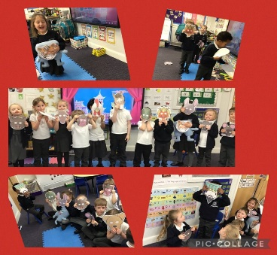
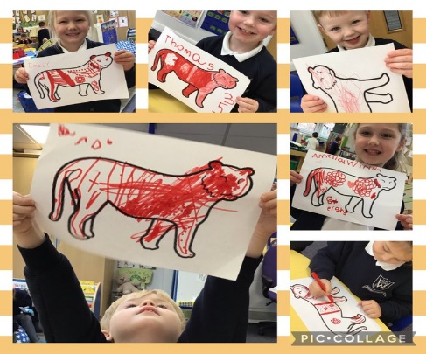
Our RE this half term has focused on Chinese New Year. The children enjoyed acting out the Chinese New Year animal race, learning about the year of the tiger and tasting some delicious Chinese food.
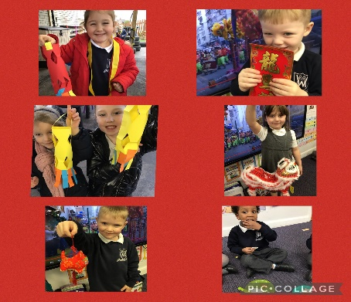

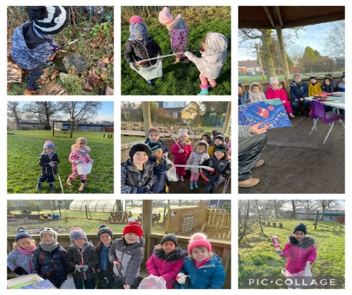

In Forest School Reception were able to learn about looking after our world. They completed a litter pick around the school and were amazed by how much rubbish they found!

