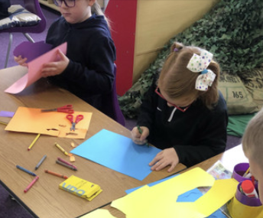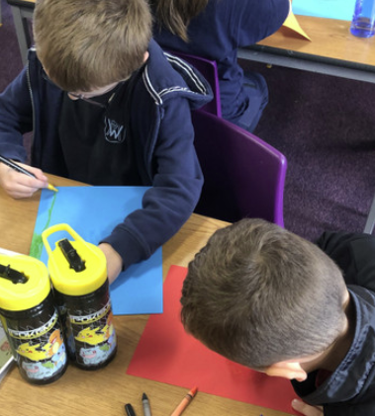

In Science, we have been looking at seasonal changes. We have been singing our seasons of the year song, talking about autumn and investigating different weathers. We really enjoyed creating our own wind socks to observe wind direction.

In English, our book has been Norman the Slug with a Silly Shell. We wrote letters to Norman, created other shells and tasted lots of yummy donuts. We wrote instructions on how to make slime. We then had the Creepy Crawly Show in school and we loved it. There has been some great recounts of the show.

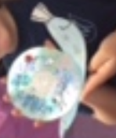

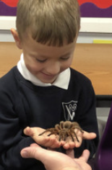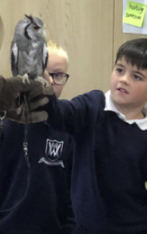

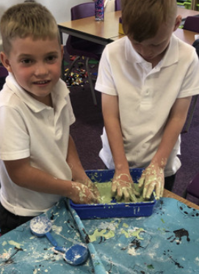

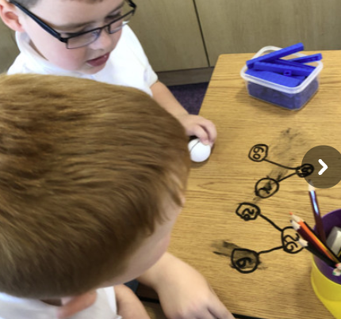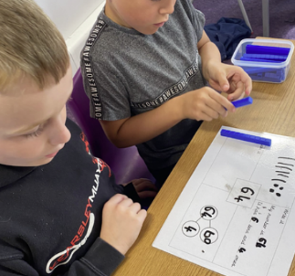

In Maths, we have been learning about place value. We have explored different ways to make numbers; we have used number lines, number squares and part whole models. We have also started to count in 2s, 5s, 10s and even 3s!

–––

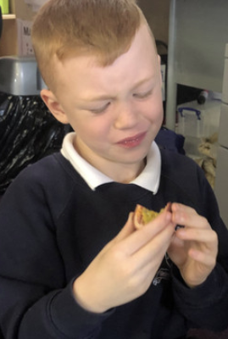

In Geography, we have been looking at Kenya as part of our Africa topic. We took our plane to Kenya, tried some exotic fruit, created some Maasai inspired jewellery and researched about Africa’s Big 5.

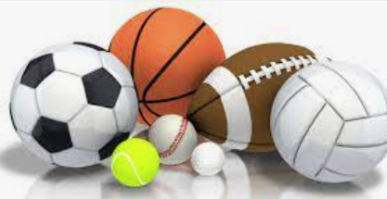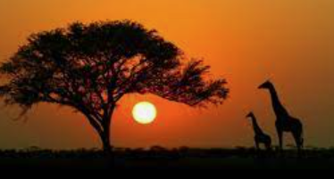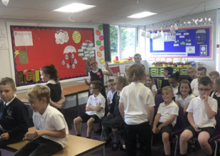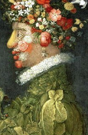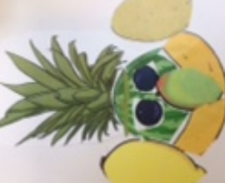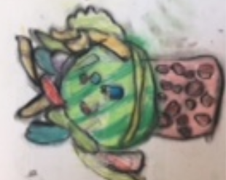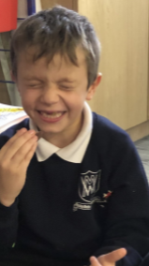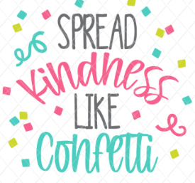

In Art, it has been all about self-portraits. Our Artist this half term has been Giuseppe Arcimboldi.

The children have used fruit to create faces, we have practised some of our drawing skills and adding light and dark to them before drawing our very own self-portrait in the style of the artist.

In PE, we have been learning some fundamental skills with Coach Lewis such as jumping, balancing. We have also been developing our throwing and catching during our Wednesday session.

In RE, our focus question has been Can we be kind to everyone all of the time? As part of this we have read two parables, The Good Samaritan and The Paralysed Man. We have had lots of discussions about kindness, when it might be hard to be kind to people and what we could do to be kind.