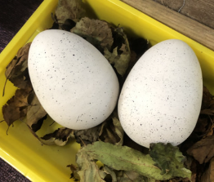

In English, our book has been ‘Never follow a Dinosaur’. The children have had lots of fun during this topic. We started with two mysterious eggs that turned out to be two little dinosaurs! We created a plan to trap a dinosaur and wrote up some super instructions. We also created a story about a Christmas Dinosaur. We were also lucky enough to have an author visit us in school and read his book.

In Science, we have been looking at different kinds of animals. We investigated if a dinosaur would make a good pet and why/why not?

First we looked through dinosaur poop to identify if the culprits were omnivores, herbivores or carnivores. We quickly established that a carnivorous dinosaur would maybe not be the best choice for a pet.

We also have classified animals in to groups; birds, reptiles, amphibians, mammals and fish. We have also discussed vertebrates and invertebrates and learnt about pets and how to care for them.

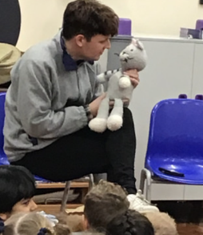

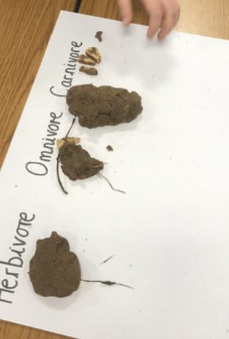

In Maths, we have been learning all about addition and subtraction. We have played lots of different games to help us develop our understanding of adding tens and ones together and subtracting tens and ones. We have learnt lots of different strategies and applied these in our mathematical investigations.

–––

In History lessons, we have been learning all about Mary Anning and what she achieved. We looked at dinosaur fossils, identified dinosaur fossils of our own, created a timeline of Mary’s discoveries and learnt all about why the dinosaurs went extinct.

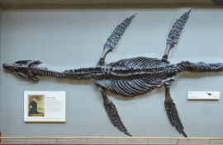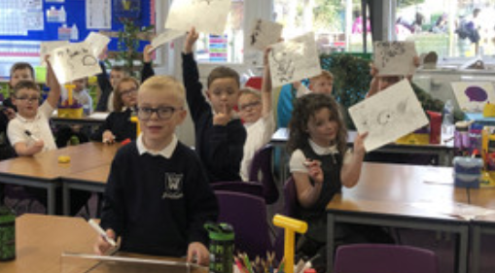

In D&T, we have been designing, making and evaluating our Ferris wheels.

In PE, we have been learning some fundamental skills with Coach Lewis such as jumping, balancing.

In RE, our focus has been on Methodism and what it means to us in a Methodist school. We were lucky enough to go on a visit to our local Methodist church and ask Rev Chris lots of questions. We also looked at the Christmas story and the importance of Jesus.