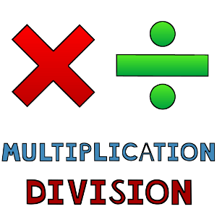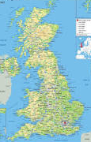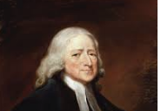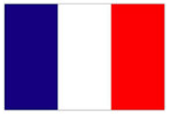

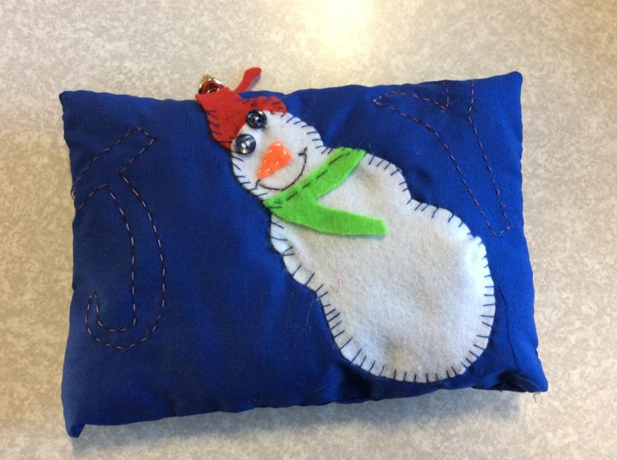 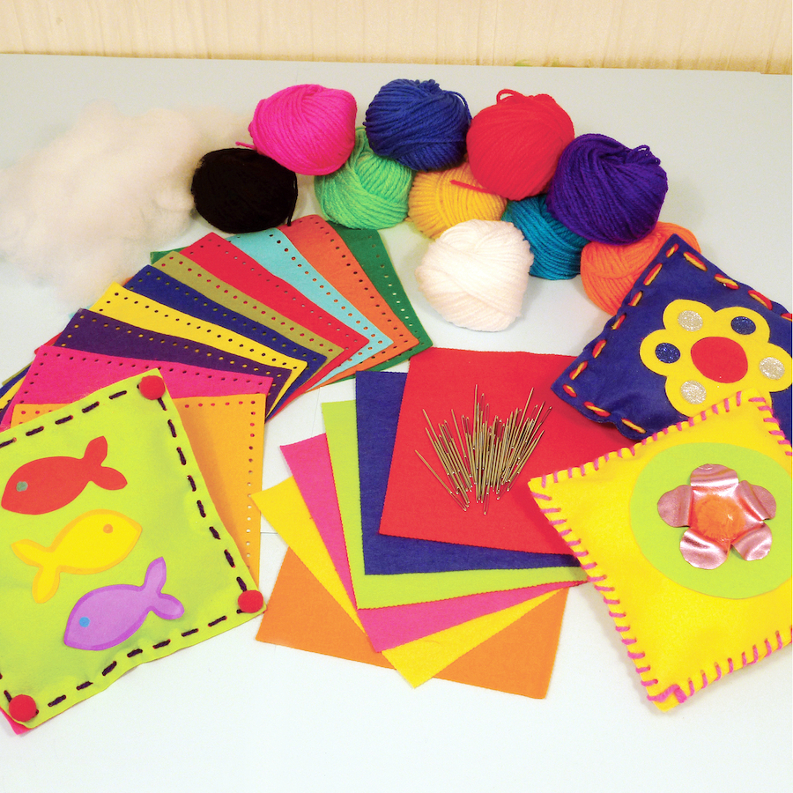

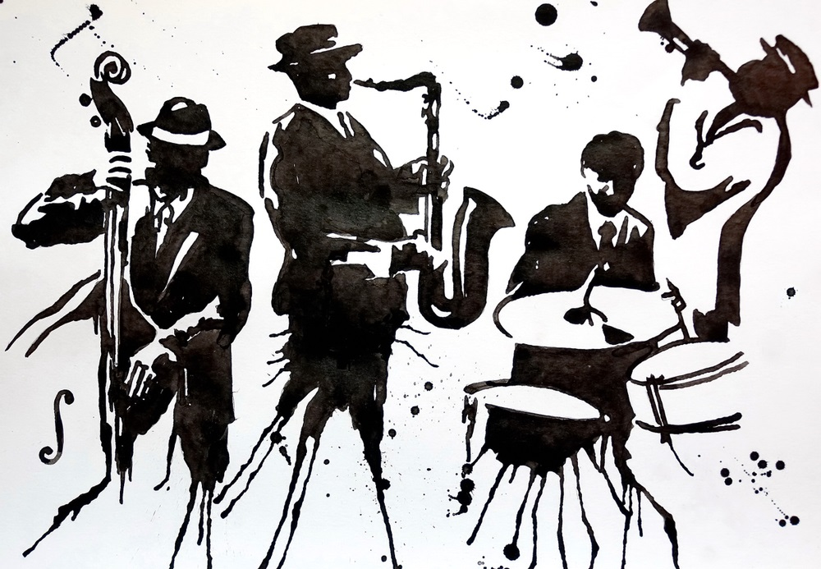

**Geography**

The focus this half term is UK.

Children will study a region in the UK, recognising similarities and differences through human and physical geography.

We will be naming and locating counties and cities in the UK.

**RE**

*Methodism*

We will be building on our knowledge of John Wesley, and what it means to have a warm heart.

*Christmas*

We will be looking at what part of the Nativity is the most significant at Christmas.

**Maths**

Year 4

Number

Multiplication and Division

Measurement – Perimeter

This term the children will be continuing with their learning of addition, subtraction, multiplication and division as well as building on their knowledge of length and perimeter.

**Music**

Looking at Performance, including Beat and Pitch.

African/American (Juba) and Polish (Plynie Statek) playground songs.

Christmas songs.

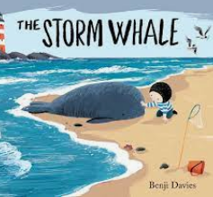

**MFL**

Phonics animal sounds

Animal habitats

Animal descriptions

Christmas

**Computing**

In computing the children will be focusing on their digital literacy whilst researching and developing a topic.



**Design and Technology**

Textiles – Cushion Making

Cross-stitching and applique

**Science**

Light

We will be recognising that we need light to be able to see.

Understanding that light from the sun can be dangerous.

Investigating how shadows are formed and how they can change.

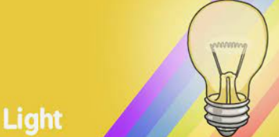

**PSHE**

**Celebrating difference**

Judging by appearances

Understanding influences

Understanding bullying



**English**

**Texts**

The Storm Whale – Benji Davies

**Genres**

Narrative

Non-chronological report

Instructions

**PE**

Gymnastics – Travelling and Balancing

Dancing – with coach