

**PE**

Fundamental skills with PE coach Lewis

PE day is Friday with Coach Lewis

**Science**

**Seasons**

The children will look observe different weathers and seasonal changes.

**PSHE**

Jigsaw- being me in my world

**Art**

Self portraits

Drawing skills- using artist Giuseppe Arcimboldi as inspiration.

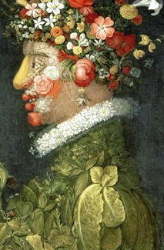

**History and Geography**

**Non- EU country**

Africa

History and Geography unit

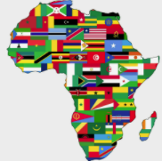

This term the children will be looking at the continents and oceans of the world. They will be comparing Bury to Kenya in Africa.

**Computing**

How to create a PowerPoint

Children will develop their typing skills and learn to create a power point using Microsoft PowerPoint.

**Music**

**Scheme of work – Sing up**

Singing

**English**

**Texts**

Norman the Slug with the Silly Shell- Sue Hendra

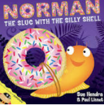

**Genres**

Narrative

Recount

**Maths**

Year 1 – This term the children will be revisiting place value and working with numbers to 10. They will then develop their knowledge of addition and subtraction before moving on to numbers to 20.

Year 2 – This term the children will be revisiting place value with numbers to 100 and then will be moving on to addition and subtraction of numbers to 100.

**RE**

*Jesus’ teachings*

*Kindness- Can you be kind to everyone all of the time?*