

**Music** 

Classical music - Compositions by Steve Reich, including Music for 18 Musicians.

**History and Geography**

**CLIMATE CHANGE – Human effects on the Tundra**

This term the children will be looking at the Tundra biome, and how climate change is affecting it. We will be comparing the Tundra biome to that of the rainforest that we studied in our previous geography unit.

**PE** 

Netball and Keeping Healthy

Agility – Reaction and Response

**PSHE**

**Healthy Me**

Understanding the impact of food on the body.

Know about the different types of drugs and their effects on the human body.

Alcohol use and misuse.

Emotional and mental health.

Managing stress.

**MFL**

**Celebrations**

**Talking about Easter, Pancake Day, Mother’s Day and birthdays.**



**Design Technology**

**Textiles - Waistcoats**

Using the skills they’ve developed over the past few years, children select fabrics, use templates, pin, decorate and stitch to create a waistcoat for a person or purpose of their choosing.



**Science**

**Animals including humans**

* Identify and name the main parts of the human circulatory system, and describe the functions of the heart, blood vessels and blood.
* Recognise the importance of diet, exercise, drugs and lifestyle on the way the human body functions.
* Describe the ways in which nutrients and water are transported within animals, including humans.

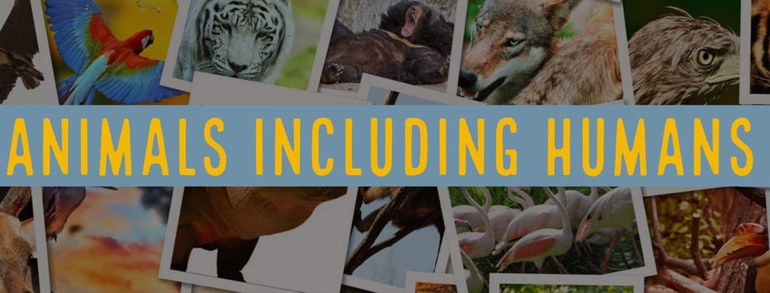

**Computing**

**Blogging**

Children will learn the basic principles of creating and maintaining a blog in a controlled and safe environment.

**Maths**

**Statistics**: Reading and interpreting graphs and charts.

**Problem solving:** Word problems involving all areas of maths covered so far.

**Ratio**

**Shape**: Properties of 2D shapes, properties of 3D shapes, problems involving shape.

**Measurement:** Volume

**RE**

**CHRISTIANITY**

Is Christianity still a strong religion, 2000 years after Jesus was on the earth?

**English** 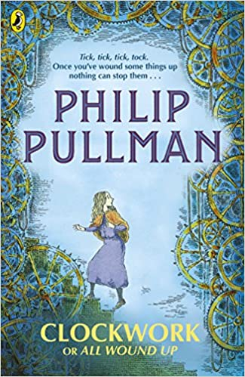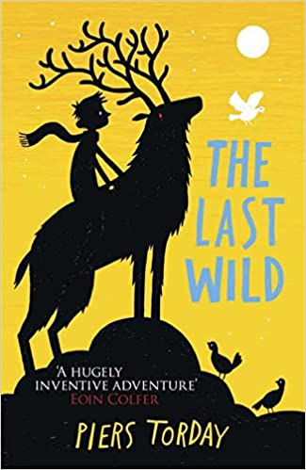

**Texts**

Clockwork

Class Novel: The Last Wild

**Genres**

Scary fiction

Poetry

Recount in role

Persuasion