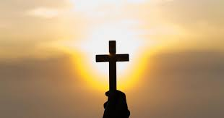

**PSHE**

**Dreams and Goals**

Setting challenges and realistic goals

Working out how to motivate yourself to achieve goals.

Identify problems within the world.

Work well with others to make the world a better place.

Describe ways to make

the world a better place.

Accepting praise.

**RE**

**CHRISTIANITY**

Is anything ever eternal?

**Maths**

**Decimals**: Multiply and divide decimals by single digit number.

**Percentages:** Calculating percentages of amounts, converting percentages to fractions and decimals.

**Algebra**

**Shape**: Properties of 2D shapes, properties of 3D shapes, problems involving shape.

**Measurement:** Converting between units of measure for mass, length, time and capacity.

**English** 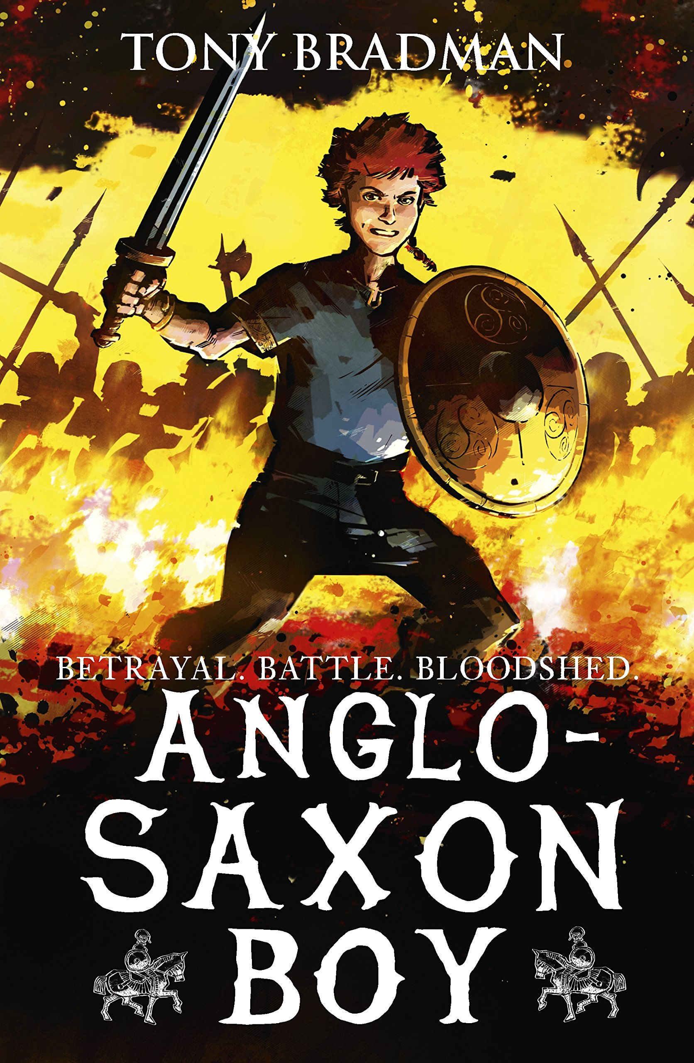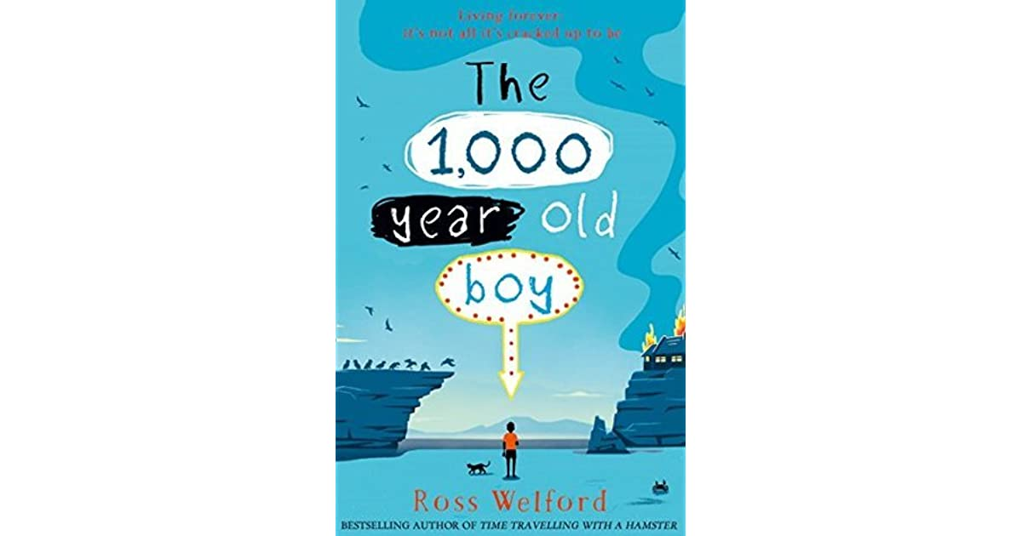

**Texts**

Anglo-Saxon Boy

Class Novel: The 1000 Year Old Boy

**Genres**

Flashbacks

Poetry

Non-chronological report

**Science**

**Materials and their Properties**

* Compare and group together everyday materials on the basis of their properties
* Know that some materials will dissolve in liquid to form a solution
* Use knowledge of solids, liquids and gases to decide how mixtures might be separated.
* Give reasons, based on evidence from comparative and fair tests
* Demonstrate that dissolving, mixing and changes of state are reversible changes
* Explain that some changes result in the formation of new materials, and that this kind of change is not usually reversible

**Art**

**Monet and the Impressionists**

Looking at the works of Monet and his influences in the art world. 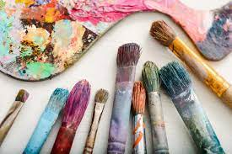

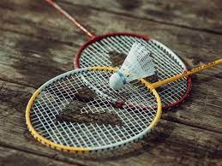

**Music** 

Classical music - Compositions by Steve Reich, including Music for 18 Musicians.

**Computing**

**Spreadsheets**

Using spreadsheets to model a real-life situation.

**MFL**

**En Ville**

**Talking about towns, what is in the town and describing places within a town.**

**PE**

Badminton

Dance

Agility – Reaction and Response

**History and Geography**

**TRADERS AND RAIDERS – Anglo Saxons and Vikings**

This term the children will be looking at the Vikings and the struggle for the kingdom of England from the Anglo Saxons. We will cover the Battle of Hastings and other pivotal moments within this time period.