Autumn 2 - Year 6
What a fantastic term this has been. The children loved show casing the Christmas Spectacular. We certainly have many talents in Year 6. Some children made us chuckle, whilst others entertained us with their acting skills and all the singers serenaded us with their beautiful voices. Everyone really shone!!
Forest School
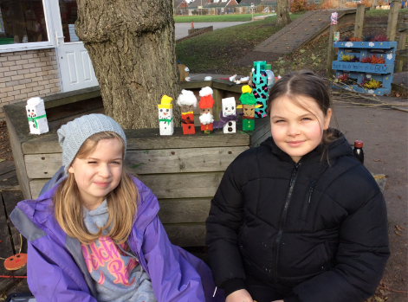
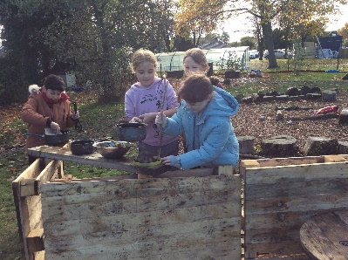
At Forest School, the children created some special poppies for Armistice Day that will last forever. They also used their imagination and created some lovely Christmas ornaments - sawing wood for these was hard work!
Some children enjoyed making dens and cooking some ‘Mary Berry’ treats in a pop-up kitchen – delicious!
Can you spot the grumpy tree?

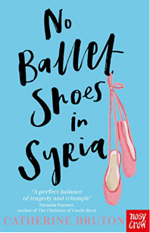
Class Novel: No Ballet Shoes in Syria
The Year 6 children were moved by a book called No Ballet Shoes in Syria.
For the 11.5 million refugee children around the globe, who have been forced from their homes and are currently seeking safe haven, the children followed the story from Syria, to Turkey, then Greece and finally Manchester, England. The incredible main character, Aya, and her perilous journey touched us all with tragedy and triumph. This story made us all realise we should follow our dreams.
The children’s writing was emotive and their vocabulary choice stunning. Well done Year 6.

Mathematics
In Mathematics, we have all been working extremely hard to get in the ‘40 Club’ – which is our weekly maths challenge. More children this term have been successful whilst others have made incredible progress. We have also been learning about Fractions, adding, subtracting, dividing, multiplying, ordering and simplifying fractions, fractions of amounts and answering problems involving the four rules with fractions. In Geometry: Position and direction, the children plotted coordinates in all four quadrants and translated and reflected shapes accordingly.
Science In Science, we have been learning about evolution and inheritance. We carried out a fair test to find how Darwin’s Finches got their beaks.
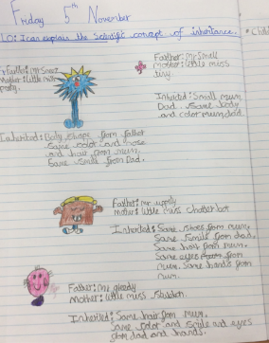
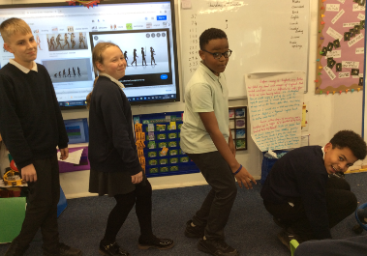
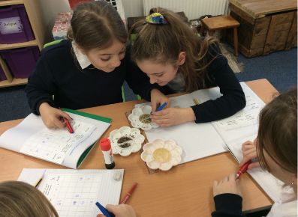
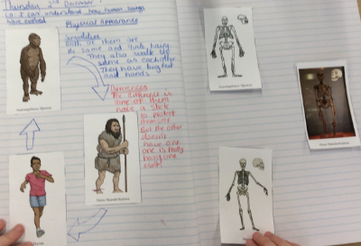
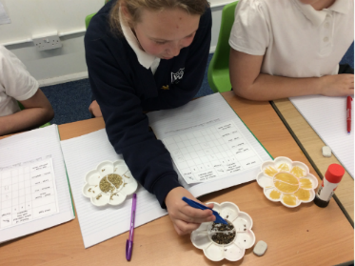
TTRockstar Day: 8th November
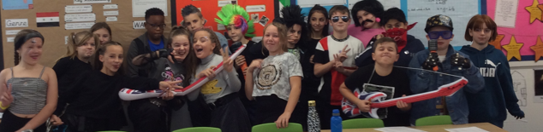
We all enjoyed getting dressed up and taking part in times table challenges.
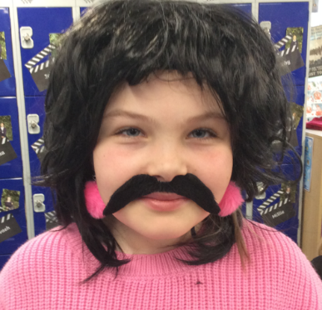
We all dug out some rock star outfits and some children had amazing face paint. Monday 8th November.

Now, who is this?

Children In Need
The children enjoyed creating their very own Pudsey Bear for Children in Need and the wait to eat them proved too much for some!!
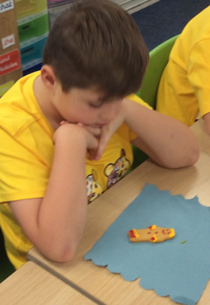
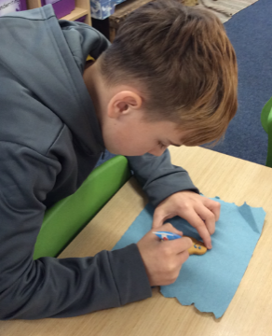
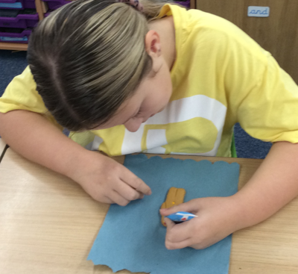
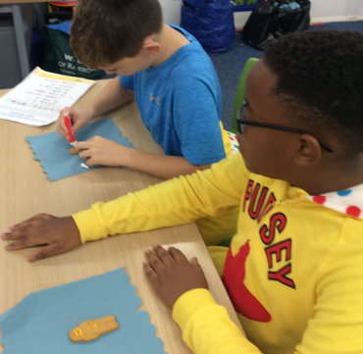
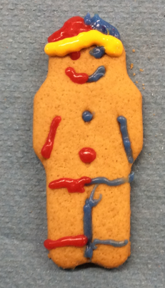

Design and Technology
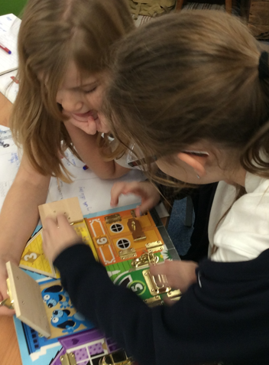
We researched and analysed a range of children’s toys before designing a steady hand game. We then assembled a circuit board to complete our electronic game. This was very tricky but the children persevered.
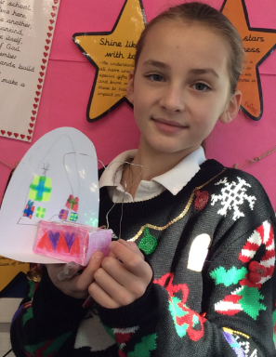
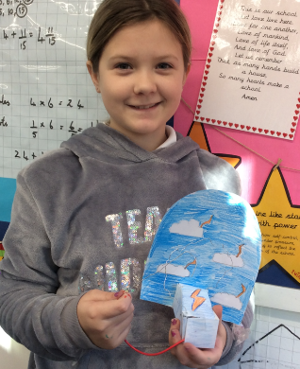
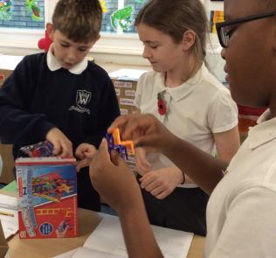

Geography
In Geography, the Year 6 children have been learning about the Amazon Rainforest and this was linked to our Class Novel, Journey to the River Sea. They created a non-chronological report on Palm Oil and its effects on the world.
French
In French, the children revised the time and how to say Quelle heure est-il?
We compared a French school day to ours. We learnt the names of different rooms in schools too.
Tres bien Year 6.

Finally, the Year 6 team would like to Wish You All a Very Merry Christmas and a Prosperous New Year.
