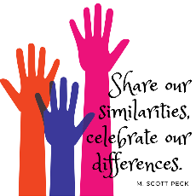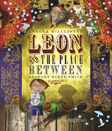

**Geography**

We will be learning to identify the position and significance of latitude, longitude, Equator, Northern Hemisphere, Southern Hemisphere, the Tropics of Cancer and Capricorn, Arctic and Antarctic Circle, the Prime/Greenwich Meridian and time zones (including day and night). Using maps, atlases, globes and digital / computer mapping to locate countries and describe features studied.

**PSHE**

**Celebrating Difference**

Accept that everyone is different

Include others when working and playing

Know how to help if someone is being bullied

Try to solve problems

Try to use kind words

Know how to give and receive compliments

**English**

**Texts**

Leon and the Place Between by Angela McCallister

**Genres**

Narrative

Non-chronological report (Place)

Newspaper report

**Science**

**Earth and Space**

We will be finding out about all the planets in our solar system, how they move around the Sun and what causes the seasons and day and night.

**DT**

**Electrical Systems**

Electric Greetings Cards

Designing an electronic greetings card with a simple electrical control circuit.

**French**

La maison et l'école

Home and School

Journey to School

Subjects

School grounds

Time and school timetables

Life in French schools:

Compare and contrast

Joyeux Noel!

**RE**

**Methodism and Christmas**

We are learning about how Methodists show commitment and to evaluate different accounts of the Christmas story and understand that different stories can be true in different ways.

**PE**

Dance – 5 Bell / Volleyball – 5 Boyle

Sports coach

**Maths**

Number - Multiplication and Division

Measure - Area and Perimeter

This term the children will be continuing their understanding of multiplication and division and be exposed to a number of word problems.

They will continue to develop their knowledge of perimeter by measuring and calculating and calculate compare and estimate areas

**Computing**

Coding with Purple Mash to make algorithms more efficient through using variables, functions and strings. We will be simulating physical systems and explore the techniques of decomposition and abstraction.



**Music**

Singing World Music – classical/modern/traditional:

***A Keelie***