

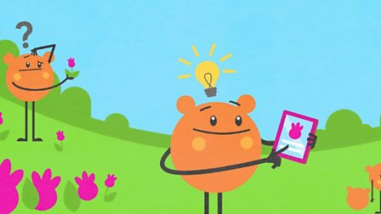



**RE**

*Methodism*

Key Question – What does it mean to be Methodist?

The story of John Wesley

The importance of John Wesley’s Mother and Brother

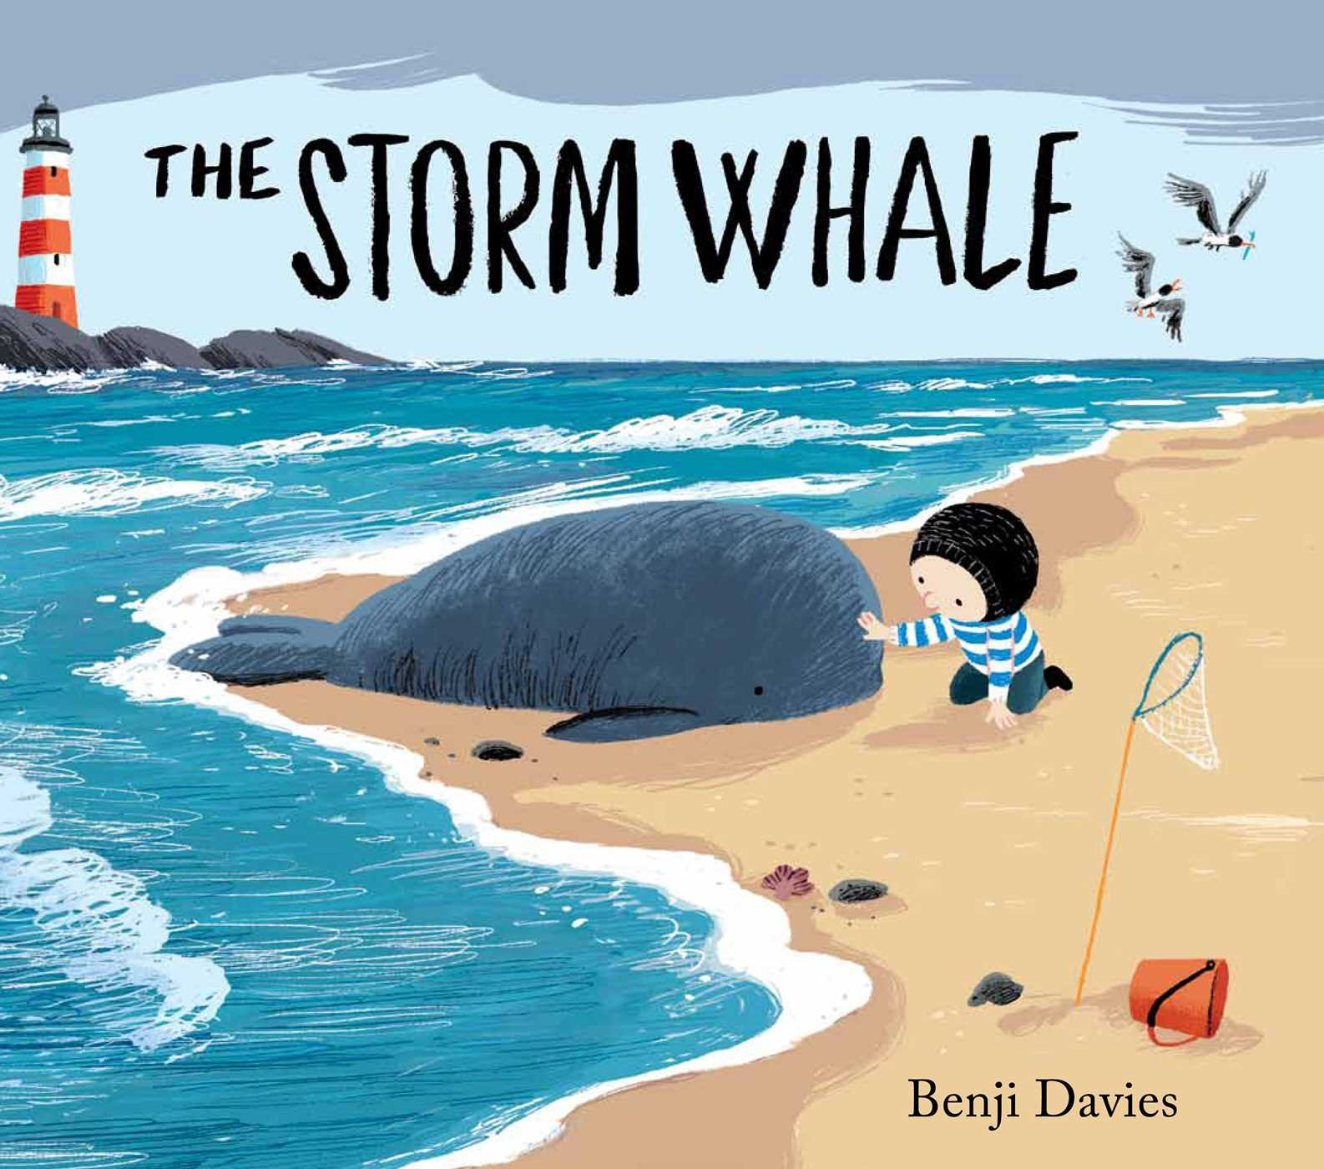

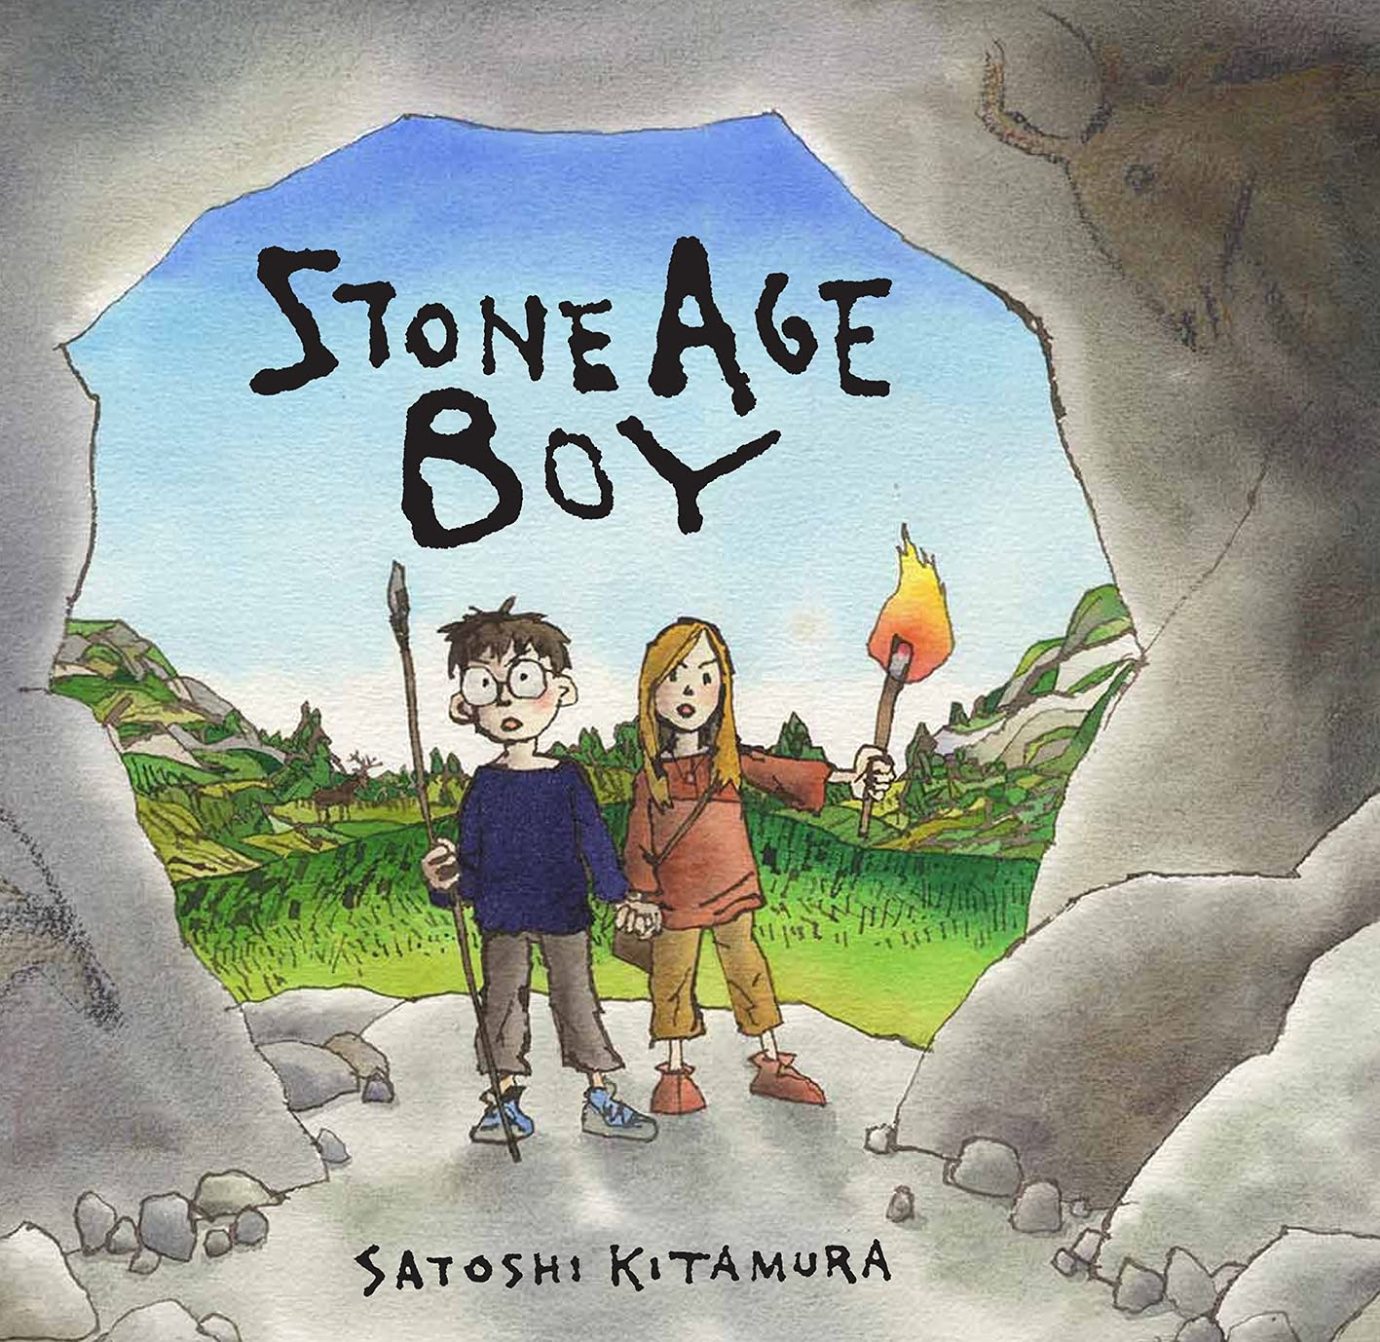

**English**

**Texts**

Stone Age Boy

The Storm Whale – Benji Davies

**Genres**

Narrative

Diary Entry

News Report

Recount



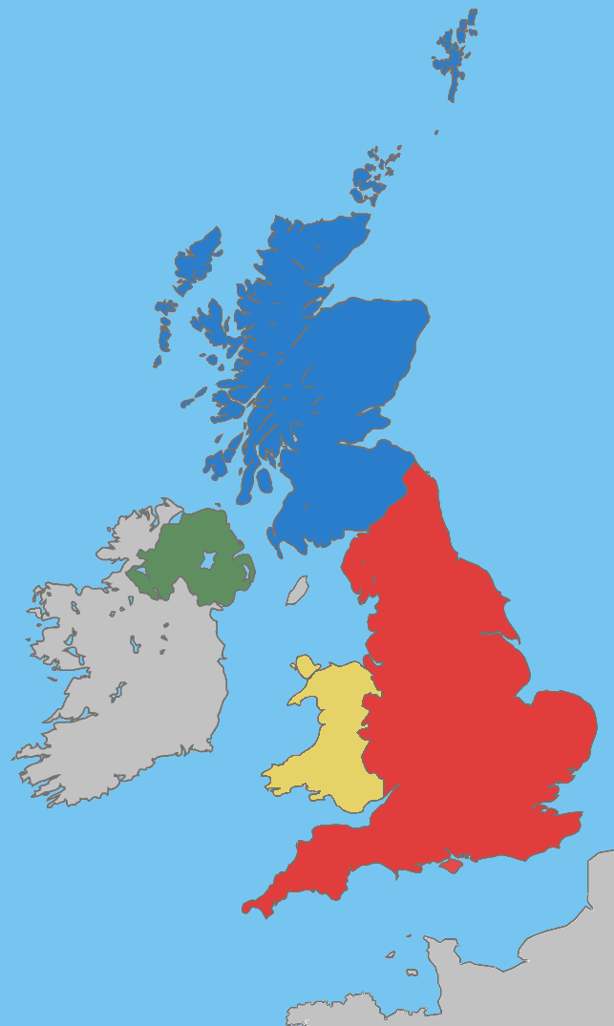

**Geography**

The UK

During this topic, children will learn about counties and cities in the UK.

Look at geographical features of a region and will identify human and physical characteristics.

**Maths** Year 3 and Year 4

Addition and Subtraction

Multiplication and Division

This term the children will be building on place value understanding and continue to develop their knowledge of addition and subtraction and moving on to more in depth work in learning their times tables and corresponding division facts.



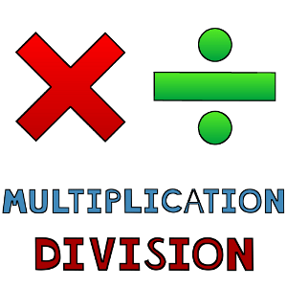

**PE**

Gymnastics – Travelling and Balancing

Dancing – with coach

**Music**

Looking at Performance, including Beat and Pitch.

African/American (Juba) and Polish (Plynie Statek) playground songs.

Christmas songs.



**MFL**

French

Nursery rhymes, playground games

Number recap 1-20

Nativite

**Computing**

Digital Literacy

Communicating online.

Finding and using the correct kind of online information.

Designing a video game character.

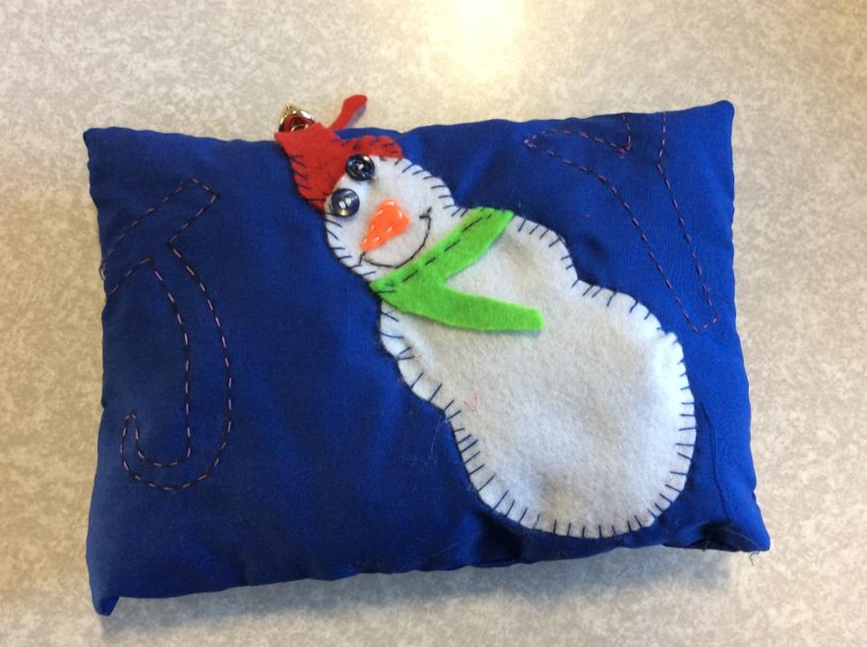

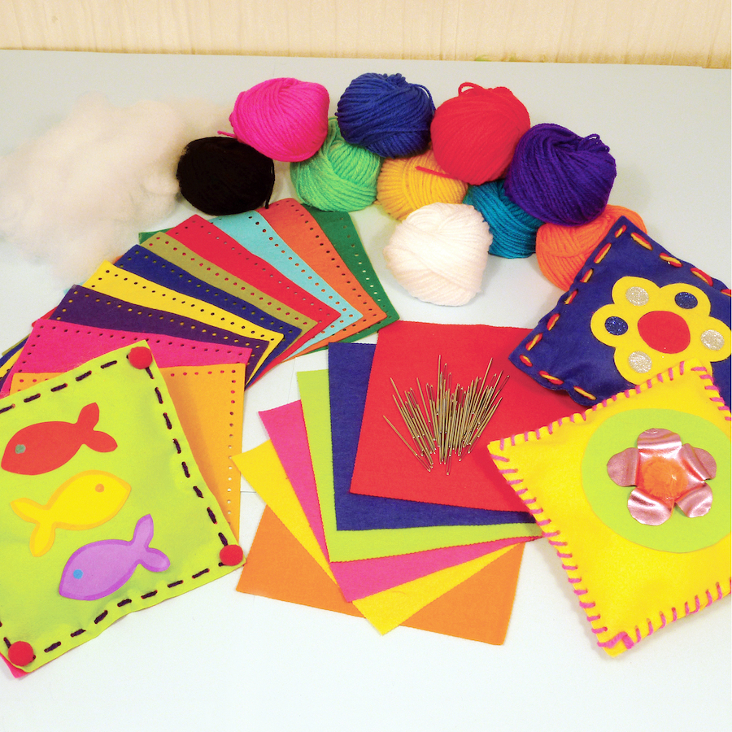

**Design and Technology**

Textiles – Cushion Making

Cross-stitching and applique

**Science**

Light

Recognise why light is important and the different sources.

Understanding shadow and reflection.

Uses for light and why it can be dangerous.

**PSHE**

**Celebrating Difference**

Accepting others

Including others

Solving problems

Giving and receiving compliments