Autumn 1 - Year 6
What a busy first half term we have had in Year 6! The children have settled into their new classrooms and are enjoying being back together after the summer holidays.
Roles and Responsibilities
We now have playground leaders, who have been trained to help others and their leadership skills are amazing and will help so many other children throughout breaktimes! Both classes voted for their class representatives and eagerly await to have a real say in issues that affect them and their class friends. Well done Ellie D and LJ.
Class Novel: Letters from the Lighthouse
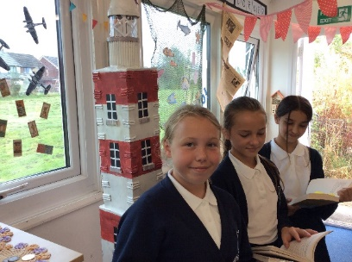
The children have been hooked with our book: ‘Letters from the Lighthouse’ this term and have asked many questions about the treatment of Jewish children and their parents during World War 11, in fact they were so engrossed they moaned when we stopped reading!!
At the end of this term, we are all looking forward to a well-deserved WW11 style party with tea and jam sandwiches – photos will be posted on Dojos.
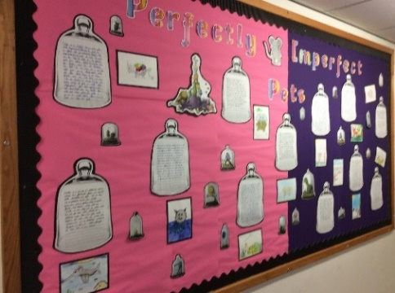
English
In English, we have enjoyed reading Barnabus, who is such an adorable character, and although he's a "failed project" he's happy with being himself and wouldn't want to change. I also think that the message about not judging others comes across really well in this story and as a result we created a lovely ‘Perfectly Imperfect display’.
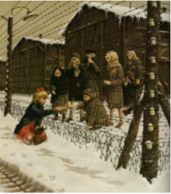
Rose Blanche
The children have also enjoyed reading a book called Rose Blanche and have written with empathy, using figurative language and imagery. Their narratives and diary entries were wonderful. This book linked to our history topic: How did children’s lives change in WW2? The children were fascinated and asked lots of questions.

Art
We loved our school art projects this term. The first one was a portrait of them themselves which are just stunning. We have also enjoyed our whole school ‘Do all you can’ art project through our Trust and the children eagerly participated with their own ideas. We can’t wait to see all the finished entries when they visit our school.
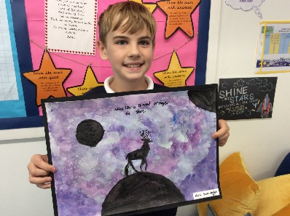
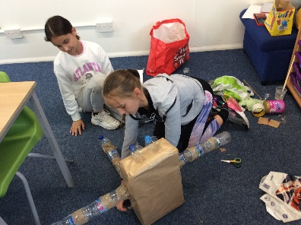
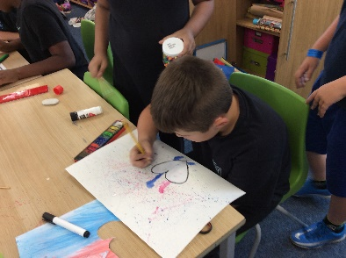

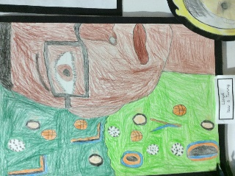
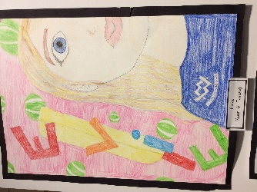

Mathematics
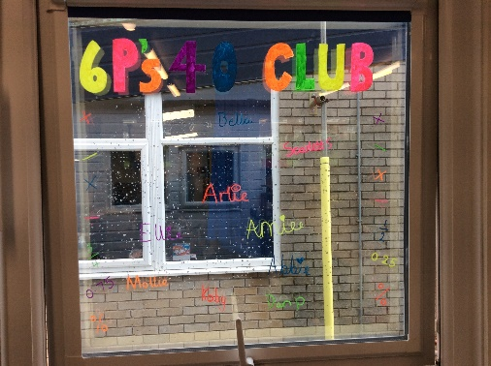
In Mathematics, we have all been working extremely hard to get in the ‘40 Club’ – which is our weekly maths objective. Some children have been successful whilst others have been beavering away at improving their scores and as a consequence are now very close to achieving it!! We have also been learning about Place value to 10 million and the Four Rules – addition, subtraction. Multiplication and division and the children have amazed their teachers with their long division skills!
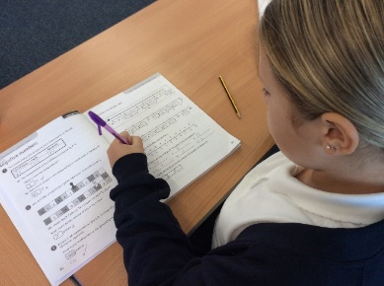

Science
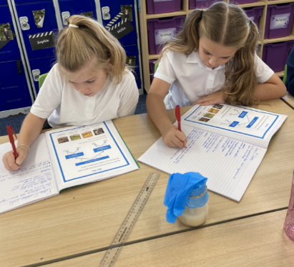
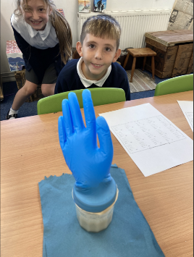
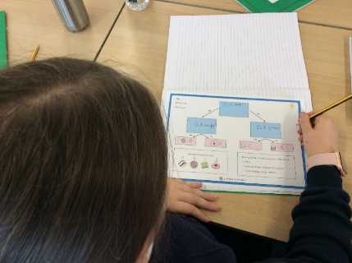
In Science this term we have been learning all about Living Things and Their Habitats. We learned how all plants and animals are classified and carried out a fair test to see if yeast was a living micro-organism, the results were spectacular!!

Forest School
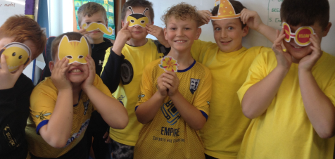
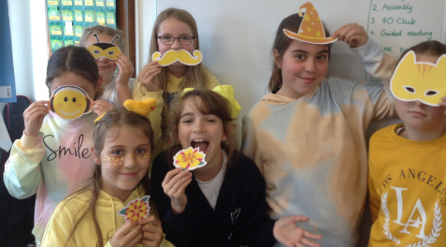
At Forest School, lots of children wanted to use tools to create some amazing pieces. All of the children listened carefully to the tool talk and implemented the rules when using them. We had our own little music jam from Jacob and LJ!!
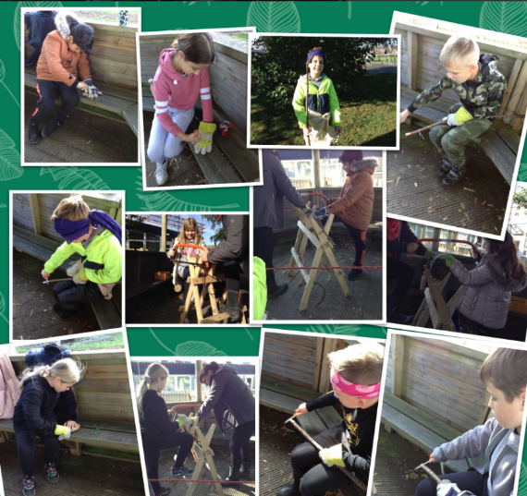
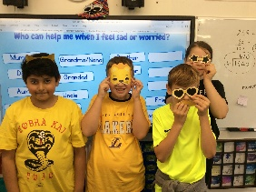

We all dug out something yellow for #Hello Yellow Day on
Friday 8th October to show that sometimes we may struggle with how we’re feeling sometimes and it’s normal to have ups and downs. Miss Wood showed us all areas online where we can access professional and safe support.

