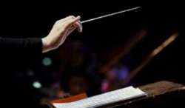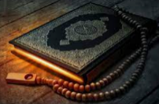

Year 2 Rashford- Curriculum map Spring term 1

**Music**

Composing

**English**

**Texts**

Literacy shed video-

Little boat

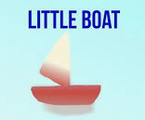

Book- A planet full of plastic

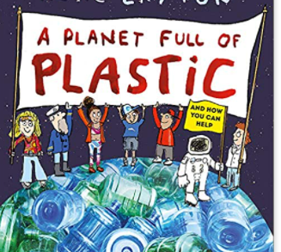

**RE**

*Islam - In our RE topic we will be learning how why Muslims pray five times a day and about commitment/focus.*

**Maths**

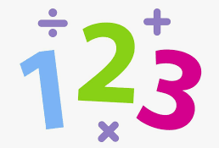

2d and 3d shapes and their properties

Multiplication and division

Children are going to be counting in 2s, 3s, 5s and 10s. So plenty of practice will really help your child in maths.

**Geography**

Our Wonderful World- learning all about the 7 continents and 5 oceans. We will also be reading ‘somebody swallowed Stanley’ then we will be looking at the impact plastic waste has on our oceans.

 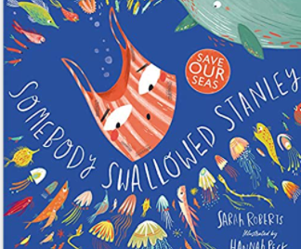

**PE**

Ball skills with PE coach Lewis

We now have a dance coach every Wednesday, please wear PE kits on this day too.

**PSHE**

Jigsaw- dreams and goals

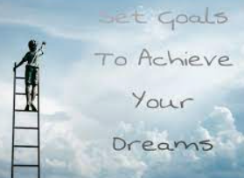

**Science**

**Uses of everyday materials**

**Year 2***will explore a range of***everyday materials***through investigations and explorations*

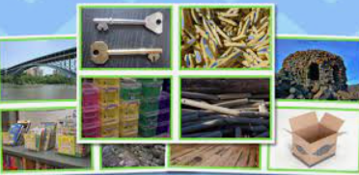

**Art**

Colour creations

Artist- Kandinsky

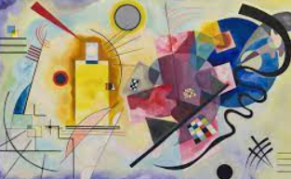

**Computing – SoW- purple mash**

Pictograms

Lego building