

**PE**

Gymnastics with PE coach Lewis

PE day is Friday with Coach Lewis

Ball Skills with Miss Kyle on a Wednesday

**Dates for diaries**

8th November- Dress as a rock star day

11th November- Remembrance Day activities in school (poppies available to purchase in school)

12th November- KS1 cinema trip

**Computing**

Online Safety

Grouping and Sorting

**Forest School**

Tuesday 9th November  
  
Tuesday 30th November

**Maths**



Year 2 – This term the children will be carrying on with addition and subtraction of numbers to 100. We will then start to look at money.

**Science**

**Living Things and their Habitats**

The children will learn about things that are dead and alive and we will look at food chains too. 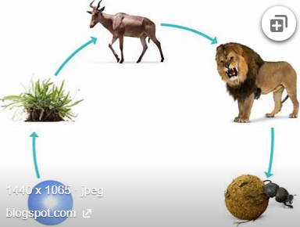

**PSHE**

Jigsaw- Celebrating Differences



**History**

**Fossil Hunters and Mary Anning**

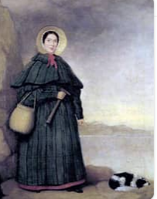 Victorian Christmas

Comparing Christmas from the Victorian era to present day.

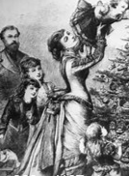

**Music**

**Scheme of work – Sing up**

Singing

Christmas Production

**Design Technology**

Mechanisms – Making a Ferris Wheel



**English**

**Texts**

Never Follow a Dinosaur- Alex Latimar

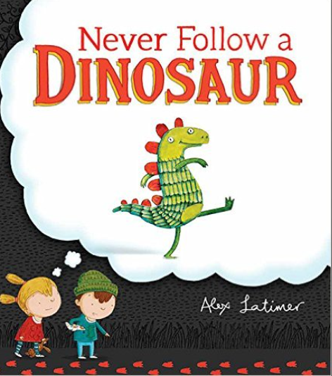

**Genres**

Narrative

Instructions

**RE**

*Methodist Unit*

*Incarnation (Christmas)- Why do Christians believe God gave Jesus to the world?*