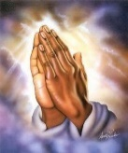

**Year Two Rashford**

**Spring 2 Curriculum Map**

**Maths**

Multiplication and Division

Fractions

Throughout this term, the children of Year Two Rashford will be developing methods relating to multiplication and division. We will exploring grouping and sharing methods through concrete and pictorial methods. This will link well to our exploration of fractions of shapes and numbers.

**Design Technology**

In design technology the children will be design and creating sliding stories.

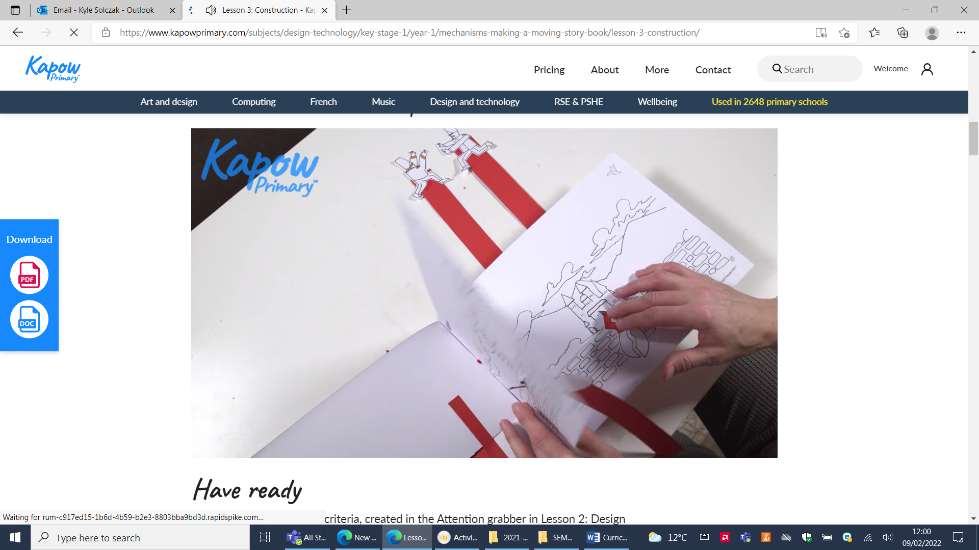

**English**

**Texts**

Bob and the Moon Tree – Simon Bartram

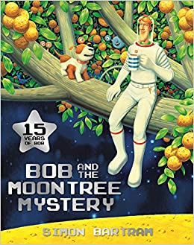

**RE**

Resurrection

How important is it to Christians that Jesus came back to life after His  
crucifixion?

**Music**

**Scheme of work – Sing up**

Composing

**History and Geography**

Moon Landing

In History, we will explore the famous moon landing in 1969.

We will ask historical questions to express what we want to know about the moon landing. We will explore the space race and how different countries raced to be the first to explore space. We will learn about animals, such as dogs and monkeys, who were sent to space before humans. Additonally, we will explore famous astronauts such as Mae Jemison, Neil Armstrong and Yuri Gagarin.

**PSHE**

Jigsaw - Healthy Me

**Science**

Plants

We will be exploring the topic of ‘Plants’. We will recap the basic structure of a plant. We will use this knowledge to observe and describe how seeds grow into plants. We will also explore what plants need to be healthy.

**PE**

Games with PE coach Lewis

Fundamental skills

PE day is Friday

**Computing**

Lego Builders

In our Computing topic, the children will be create simple instructions and recipes using Purple Mash to scaffold the learning.