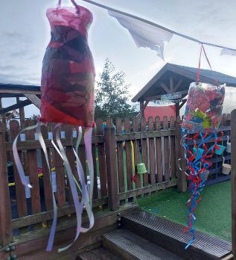

In English, our book has been Norman the Slug with a Silly Shell. We wrote letters to Norman, created other shells and tasted lots of yummy donuts. We then had the Creepy Crawly Show in school and we loved it. There has been some great recounts of the show.

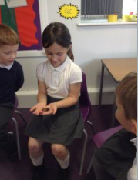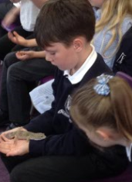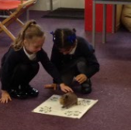

In Science, we have been looking at seasonal changes. We have been singing our seasons song, talking about autumn and investigating different weathers. Outside we have our own weather station, where we have been measuring the rainfall and checking to see which direction the wind has been blowing. We have also been investigating shadows.

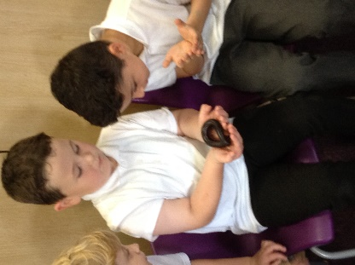

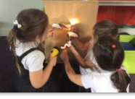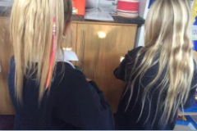

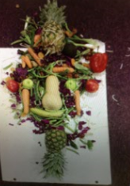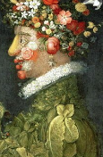

In Art, it has been all about self-portraits. Our Artist this half term has been Giuseppe Arcimboldi.

The children have used fruit to create faces, we have practised some of our drawing skills and adding light and dark to them before drawing our very own self-portrait in the style of the artist.

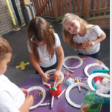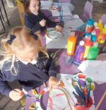

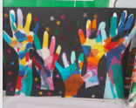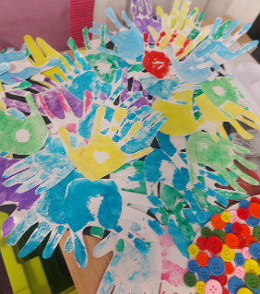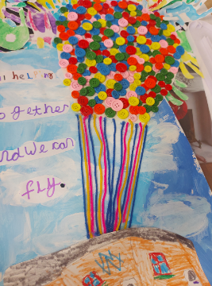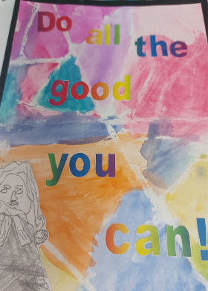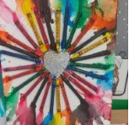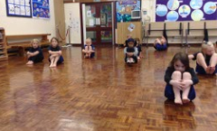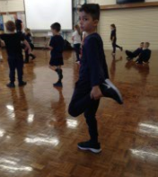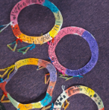

In PE, we have been learning some fundamental skills with Coach Lewis such as jumping, balancing etc.

With Mrs Thomasson, we have been practising some gymnastics skills such as performing different pike, tuck, straddle shapes, travelling in a variety of ways.

Trust Art Project across all the schools, the theme was ‘Do all the good you can’. This is what we created.

In Geography, we have been looking at Kenya as part of our Africa topic. We have found out some interesting facts about Kenya, tried some exotic fruit, created some Maasai inspired necklaces and researched about Africa’s Big 5.

In RE, our focus question has been Can we be kind to everyone all of the time? As part of this we have read two parables, The Good Samaritan and The Paralysed Man. We have had lots of discussions about kindness, when it might be hard to be kind to people and what we could do to be kind.