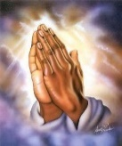

**Music** 

Scheme of work – Sing up

Skill- Singing

**PE**

Games with PE coach Lewis

Fundamental skills

**PE day is Friday- please send in a labelled PE kit**

**Science**

Seasons of the year

The children will look observe different weathers and seasonal changes. 

**History and Geography**

**Non- EU country**

Africa

History and Geography unit

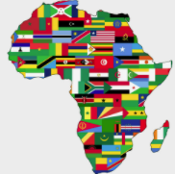

This term the children will be looking at the continents and oceans of the world. They will be comparing everyday life in Bury to everyday life in Kenya, Africa.

**Art**

Self portraits

Drawing skills- using artist Giuseppe Arcimboldi as inspiration.

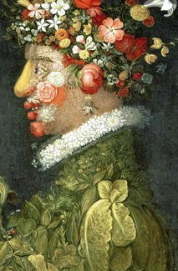

**Computing**

How to create a PowerPoint

Children will develop their typing skills and learn to create a power point using Microsoft PowerPoint.

**RE**

*Jesus’ teachings*

*Kindness*

**English**

Norman the slug with the silly shell- Sue Hendra

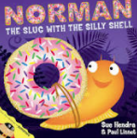

**Genres**

Narrative

Recount

**PSHE**

Jigsaw- being me in my world

Children will learn about and explore rewards and consequences, rights and responsibilities and hopes and fears.

**Maths**

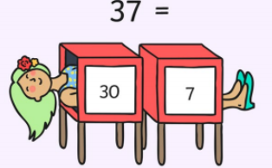

Place value- understanding numbers

Addition and subtraction

This term the children will be recognising numbers and understanding the value of numbers. In place value, we will learn about more than, less than, ordering numbers, comparing number and counting in 2s, 5s and 10s.

In addition and subtraction, we will look at adding and subtracting small numbers using a range of strategies.