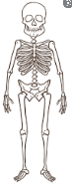

**French** Où habites-tu? Where do you live? Pupils will say their nationality, the country they live in and the language they speak. They will also use the negative tense and read Boucles d’Or – Goldilocks and the Three Bears…in French. (For Year 3 see below)

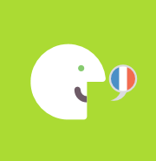

**Computing** Spreadsheets and GraphingWe will create pie charts and bar graphs. We will look at 2Graph on purple mash and use it to solve investigations. 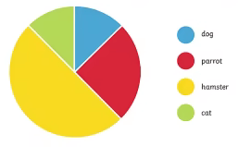

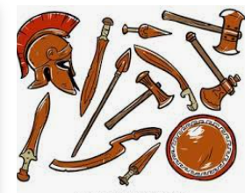

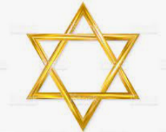

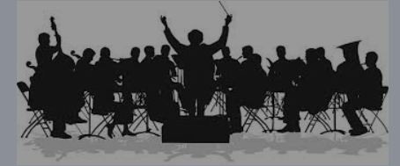

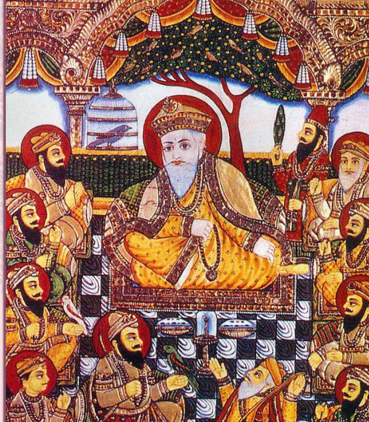

**History**

The focus this half term is the Bronze and Iron Age.

We will be looking at how things changed for Great Britain, from the Stone Age to the Iron Age. We will use our learning from autumn to help us with this.

**RE**

Judaism

This half term we will be returning to our unit on Judaism. We will be specifically learning about the Passover whilst discussing why it might be important for Jewish people to do as God asks them to.

**Maths**

In maths we are continuing on our learning from last half term on multiplication and division.

Towards the end of the half term we will be learning all about money.

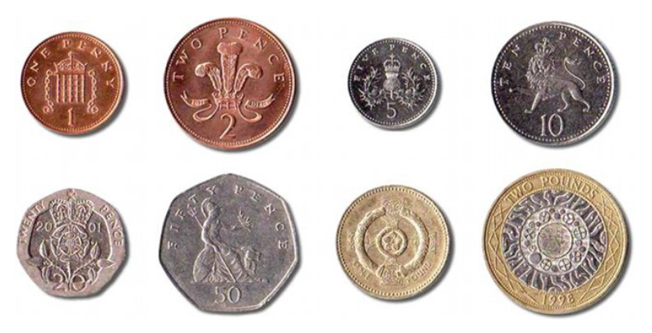

**Music**

Our focus for music this half term comes from orchestral music created by Florence Price. We will be listening to, and creating our own piece of music.

**Art**

In art we will be focusing on Indian art and using printing skills to create some beautiful art. We will also be focusing on a local Manchester artist for our drawing lessons.

**Science**

Humans

In science this half term we are going to be learning about what humans and other animals need to survive. We will also be learning how skeletons and muscles are used.

**PSHE**

**Dreams and goals**

We will be learning about hopes and dreams, broken dreams, overcoming disappointment, creating new dreams and achieving goals. 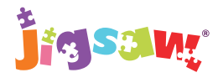

**English** The Fastest Boy in the World

Eleven-year-old Solomon loves to run! The great athletes of the Ethiopian national team are his heroes and he dreams that one day he will be a gold-medal-winning athlete like them, in spite of his ragged shorts and bare feet. **Genres** Narrative

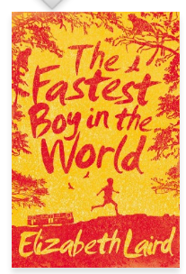

**PE**

‘New year, new you’ Health and Fitness with Coach Lewis. Net and racket focussing on Badminton.

Year 3 French

Mon Anniversaire – My Birthday

Pupils will talk about their birthday, write a party invitation and play party games. They will read Boucles d’Or - Goldilocks and the Three Bears…in French.