**Spring 1 Highlights**

**Year 3/4 Walsh**

This Term there was some very exciting news for 3/4 Walsh…

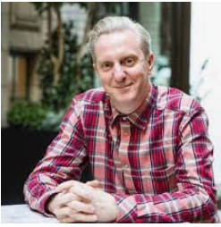

As I’m sure you know, our class is named after the brilliant Mancunian poet, Tony Walsh. He is most well-known as the poet who wrote the touching poem, ‘This is the Place’, that he shared with the world to commemorate the lives lost at the Manchester Arena bombing. At the start of term, we read his poem ‘Bohemian Raspberry’. The children really enjoyed the poem (spontaneous applause followed the first reading) and they were inspired to write their own emotion poems. We presented these on Word and have displayed them in the hall. I tweeted about the poetry we had enjoyed and written, and included photos – see below. I sent the message to Tony Walsh…and he replied!!! I wasn’t expecting a response as I know how busy he must be. He was so honoured to have a class named after him and loved that the pupils were writing poems of their own. He has offered to do a Live Zoom session with our class in the near future!! And may even visit us when Covid restrictions allow the classes to gather in the hall once more. Wow!

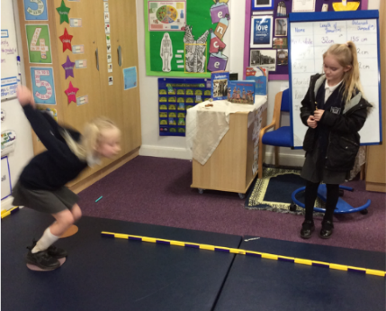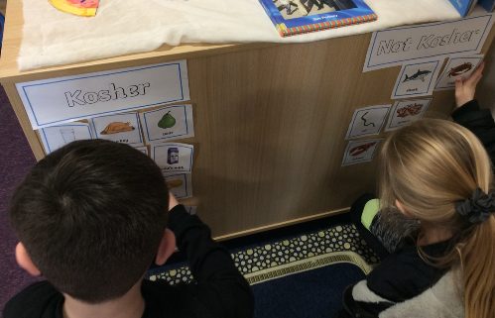

As part of our Science topic, Humans, we did an experiment to find out if people with a larger femur would be able to jump further. Ask your child to find out what we discovered…

In RE we were learning about Judaism. We considered Kosher foods and the pupils planned a Jewish child’s party menu. Here they are sorting food in our interactive display in the Worship area.

In Maths, we have really stepped up our times tables practise ready for the Year 4 speed test. Many children are joining the 60 Club and are beating their times each day. Some pupils are now completing the test in under two minutes and even one minute! I am so proud of all their achievements in Maths this term!

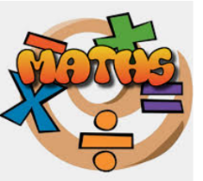

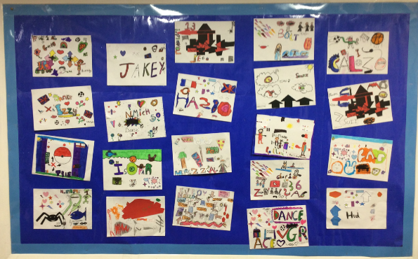

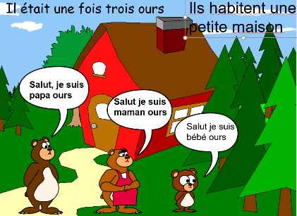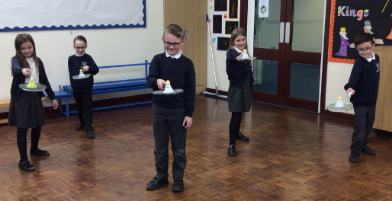

On Art Day, we looked at local artist, Kelzo, and produced our own Graffiti Art in this style. They looked brilliant on display in class.

En français...

We read Boucle d’Or Boucles d’Or – Goldilocks and the Three Bears… and pupils learned to say their nationality, the country they live in and the language they speak.

In PE, we practised to improve our badminton skills and got fit with Coach Lewis. It was hard work for us all (me included) but we have all got a little fitter as the weeks went on.