**Autumn 1 Highlights**

**Year 3/4 Walsh**

What a super start to life in Year 3 / 4 it has been! The children have settled into their new routines well and have worked so hard. We are very proud of their efforts and achievements.

This is what the children have to say:

We read Eleanor’s Eyebrows and used it to write similar stories of our own. Later we wrote instructions for a magical potion to regrow missing body parts.

“I liked doing Eleanor’s eyebrows.” Jake

“I have enjoyed writing Ella’s teeth.” Lexi

“I liked doing the potion work.” Harry R

“I loved writing about the magical potion instructions…” Jayden

“I love Stone Age Boy!” Narla “I loved when we did Stone Age Boy.” Tyler

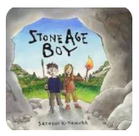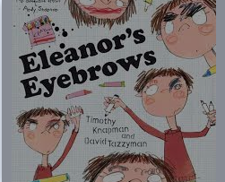

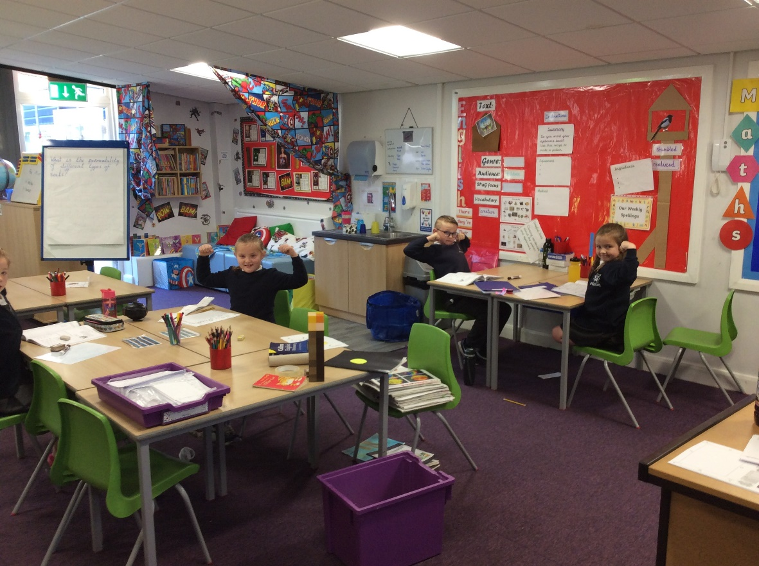

In Maths lessons we have been improving our four rules of addition, subtraction, multiplication and division.

“I love doing the Flashbacks in Maths.” Theo

“I like doing Flashback.” Reggie

“Can we do this all day?” Harry T about Power Maths Checking Strategies work

“I loved the Times Tables Rock Stars Test!” Riley

“I enjoyed doing Maths so I can learn.” Lola

“I love Maths.” Reuben

I love going on the laptops …it helps me with my Maths.” Olivia

**Power Maths!**

**Grrrrrr!**

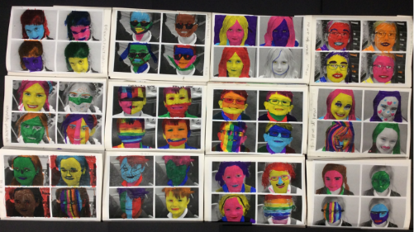

En français...

We have been learning our numbers. Can you say the numbers the pupils are making here…in French? Answers below.

“I like French because we learnt how to introduce our family.” Farrah

I Love French when we learn about numbers. Gabriel

I love when we do French in our français books. Tyler

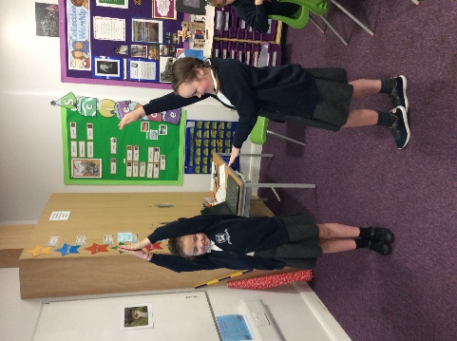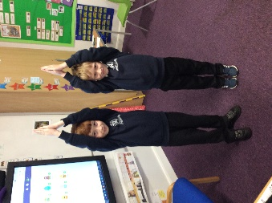

In Art, we looked at Pop Art and produced self-portraits in the style of Andy Warhol.

“I love the way that we do Art because it’s fun- sometimes hard, sometimes easy.” Isobel

“I did a really good job drawing a Pikachu with a Santa hat.” Amir

And so much more…

“I love science working with my friends on fun experiments. Watching the water sink through the soil was amazing.” Keira

“I really liked doing Music because I liked singing.” Mabelle

I love playing bench ball in P.E.” Emmanuel

“I loved being with my friends.” Callum “I love forest School.” Narla

“My highlight was Forest School with Mrs Seal. I loved being outdoors with the class and saw a different side to the pupils. I hope some hedgehogs visit the little wooden house to eat the food I brought in.” Mrs C

“I have really enjoyed teaching Year 4 Maths. They have put in so much effort and are making good progress.” Mrs Lonsdale

French Answers: Onze et treize