**Autumn 2 Highlights**

**Year 3/4 Walsh**

What a busy term it has been! The children continue to work hard and we are so proud of their efforts and achievements.

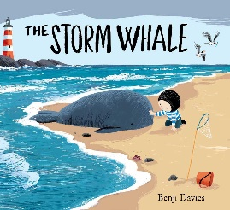

We read The Storm Whale and wrote similar stories about animals that had lost their way. Later, we did some research and wrote fabulous non-chronological reports about whales.

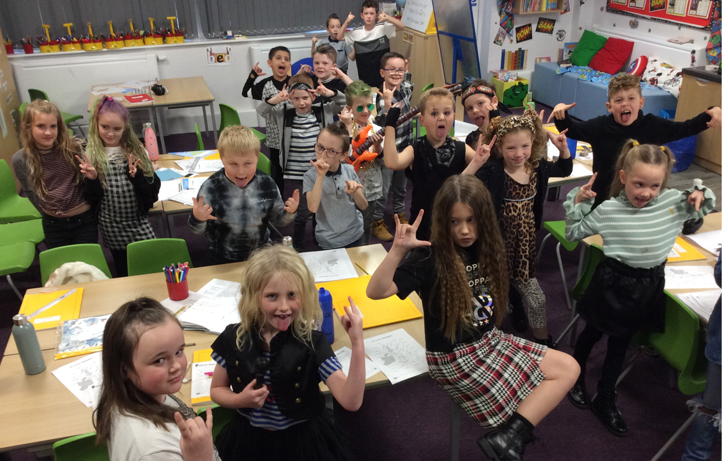

TT Rock Stars Day: Monday 8th November

We spent the morning playing Maths games and improving our times tables skills on TT Rock Stars and Hit the Button.

We need rapid recall of our tables facts…especially in Year 4 for the National Test at the end of the year. This test is done on a computer screen just like on TT Rockstars so it really is the best practise. Look out for a challenge from your teacher if you are logging on regularly. Can you beat Mrs’ total?!

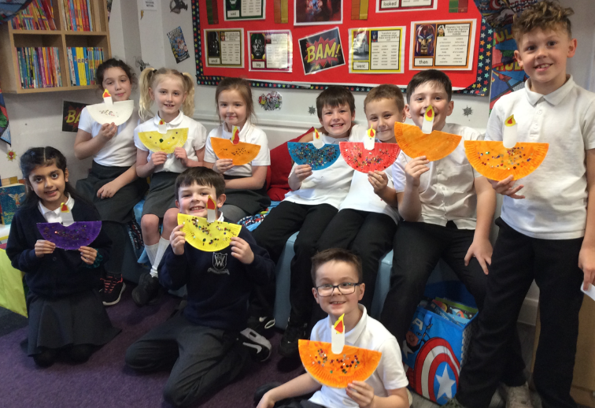

In Design Technology, we designed and made a Christmas stocking. Expert sewers Mrs Lightowler and Mrs Harris came in to help and were so impressed with how patient and calm our pupils were when sewing, even when they couldn’t thread their needles! They are lovely children and do make us smile every day.

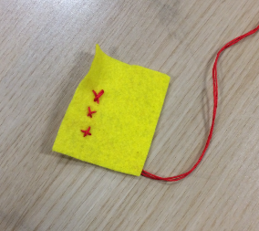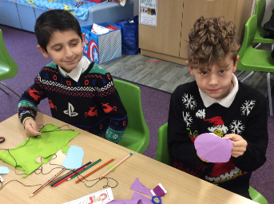

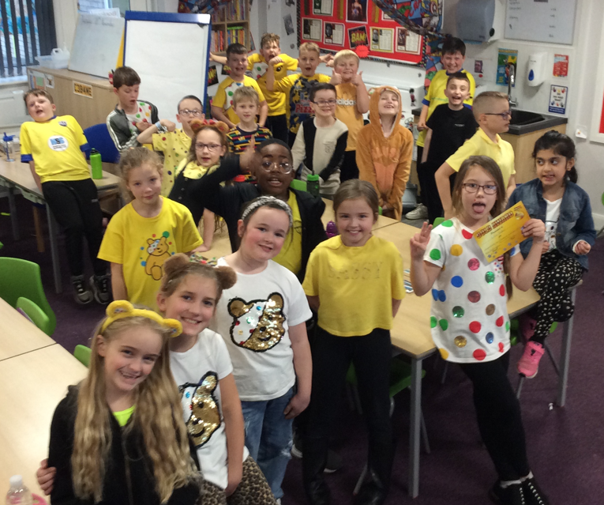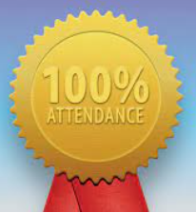

Raising money for Children in Need

Monday 24th October

Making Diwali lamps to celebrate the Hindu religious holiday, “the festival of lights”

Despite it being winter and a virus or two being out there, 3 / 4 Walsh achieved 100% attendance last week. (Monday 6th December – Friday 10th December)

Well done pupils and parents too for getting the children into class every day. We have had another good week this week too so fingers crossed we get the award again…