

**English**

**Text**

Bob and the Moon Tree Mystery by Simon Bartram

**Genres**

Newspaper report

Setting Description

Narrative

Explanation Text

Job Advertisement

**Science Plants** Children will be becoming plant explorers and investigating parts of plants and trees. They will be identifying trees to see if they are deciduous or evergreen. We will be conducting 2 experiments too, one to see what is important for a plant to grow and the other is to observe changes to a sunflower as it grows.

**PSHE**

**Jigsaw- Healthy Me**



**PE**

Track and Field with PE coach Lewis on a Friday.

Target Games on a Wednesday.

**History**

**Moon Landing – Neil Armstrong**

Children will be learning about Neil Armstrong and how he is an important historical figure. We will be creating a non-chronological report about him and the famous event, The Moon Landing.

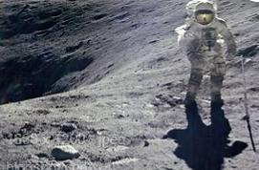

**Music**

**Scheme of work – Sing up**

**Composing/Listening**

Patterns/Notation/Musical History

**Forest School**

**Thursday 3rd March**

**24th March**

**Art**

**Painting – Colour Creations and Kandinsky**

Finishing this art unit from last half term

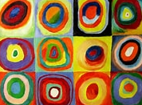

**Computing**

**Lego Builders – Using algorithms**

**Maze Explorers -** To create a set of instructions using directional keys

**Animated Stories** – To create their own animated story on Purple Mash with sounds and pictures.

**Maths**

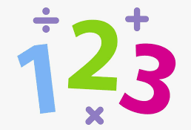Year 1 – This term the children will be working with numbers to 20 before using addition and subtraction with these numbers. We will then move on to fractions and identify ½ and ¼ of a shape, quantity and number.

Year 2 – This term the children will be identifying coins, working out amounts and change in money. We will then move on to fractions of a shape, quantity and number.

**RE**

**Easter – Salvation**

**Key Question –** How important is it to Christians that Jesus came back to life after His crucifixion?