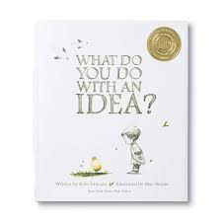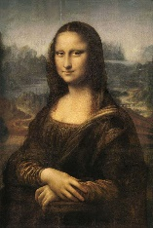

**PE**

Games and fitness

Sports coach

**French**

Alphabet

Directions

Celebrations

Lunchtime

Food Likes and Dislikes

Building Sentences

Food for a Celebration

**Maths**

Place Value – up to numbers within a million

Number – addition and subtraction

This term the children will be continuing their knowledge on place value within 100 000 then within 1 000 000.

They will continue to develop their knowledge of addition and subtraction and be exposed to a number of word problems.

**PSHE**

**Being Me in My World**

The children will be learning to:

Help others to feel welcome

Try to make our school community a better place

Think about everyone’s right to learn

Care about other people’s feelings

Work well with others

Choose to follow the Learning Charter

**History**

GODS AND MORTALS – A study of Greek life and achievements and their influence on the western world.

Who were the Ancient Greeks?

Why were Athens and Sparta so different?

What was Alexander the Great’s impact on the Greek empire?

Why did a small Greek army win the Battle of Marathon?

What were the Ancient Greek gods known for?

What happened at the Ancient Greek Olympic Games?

**Science**

**Forces**

The children will look at the different types of forces and how they can affect the world around them, including gravity and friction.

**English**

**Texts**

What do you do with an idea/ problem? By Kobi Yamada

Tuesday By David Wiesner

The Boy at the Back of the Class

By Onjali Q. Rauf

**Genres**

Narrative

Newspaper report

**Computing**

Using Scratch to build and edit algorithms for simple games. The unit is designed to help children develop their skills in writing their own algorithms as well as editing and debugging existing codes.

**RE**

**Hinduism – Prayer and Worship**

Commitment

Puja and Prayer

Vedas and Dharma

Pilgrimage

**Art**

Drawings based on / inspired by the work of Leonardo De Vinci.

**Music**

Singing World Music – classical/modern/traditional:

***Dem Bones, Mama don’t allow, Madina tun Nabie, A Keelie***