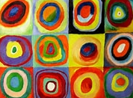

**English**

**Texts**  An animation text – Little Boat

A Planet Full of Plastic and How You Can Help by Neal Layton

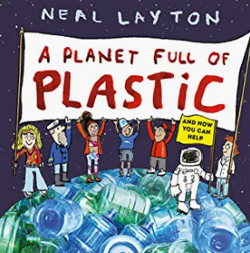 **Genres**

Descriptions, letters, posters

Poems

Non-Chronological Report

**Science**

**Everyday materials** The year 1 children will recognising, grouping and identifying the characteristics of different materials. Year 2 children will be expanding on this and looking at the everyday uses of these materials before planning and carrying out an investigation.

**PSHE**

Jigsaw- Dreams and Goals

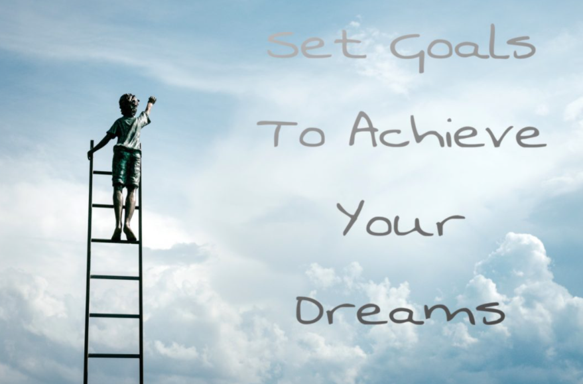

**PE**

Ball skills and Basketball with PE coach Lewis on a Friday.

Dance with a Dance Coach on a Wednesday.

**Geography**

**Our Wonderful World**

We are going to be naming and locating different continents and oceans around the world.

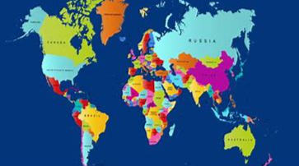

**Music**

**Scheme of work – Sing up**

**Composing/Listening**

Patterns/Notation/Musical History

**Forest School**

Tuesday 11th January  
  
Wednesday 2nd February

**Art**

Painting – Colour Creations and Kandinsky

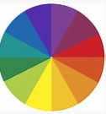

**Computing**

Pictograms

Lego Building

**Maths**

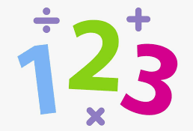Year 1 – This term the children will be learning about 2D and 3D shape and then we will be looking at multiplication and division.

Year 2 – This term the children will be identifying the characteristics of 2D and 3D shapes and we will then move on to multiplication and division which will help us when we start money in Spring 2.

**RE**

*Prayer at home - Islam*