Autumn 1 Reception Highlights
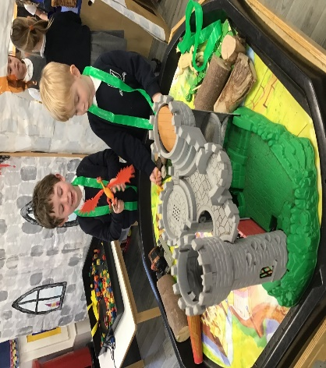
We have had a fantastic first half term of the year and are so impressed with how the children have settled into their new school. We have had some wonderful adventures into the jungle and the world of dragons in literacy and have been amazed by the children’s super phonic skills. The children have embraced their maths and literacy challenges and we cannot wait to carry on the wonderful learning journeys in Autumn 2.
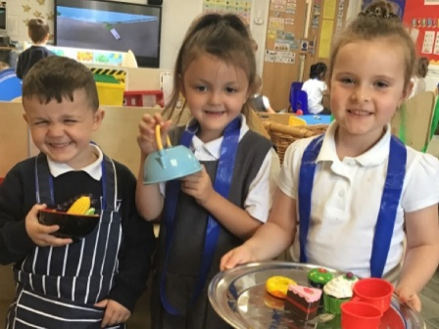
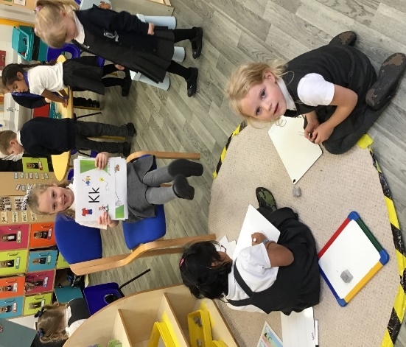
So many wonderful friendships have already been made and the children have grown in confidence in their new setting.
There have been many dragon adventures in the small world area linked to our class text “Zog”.
The children have loved playing the role of the teacher and practising their phonic skills.

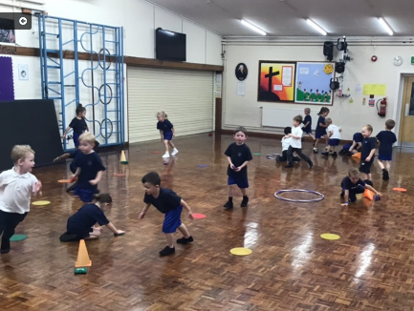
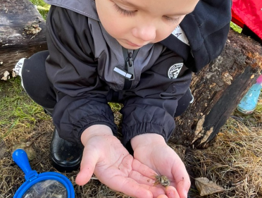
Two extra special highlights for the children have been PE with Lewis and Forest School with Mrs Seal. The challenge of getting changed has been worth it to play fun games in the hall with Lewis working on following instructions and teamwork. Forest School was also quite daunting for our first session but the children have loved bug hunting, playing in the mud kitchen and listening to fabulous stories from Mrs Seal – some of the children even held frogs and wanted to take slugs home as pets!
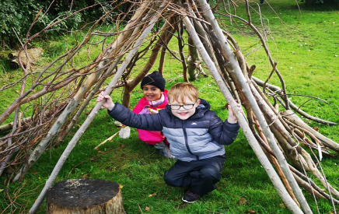

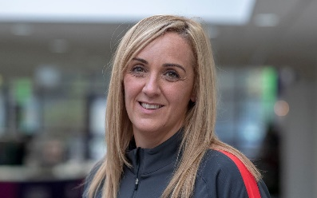
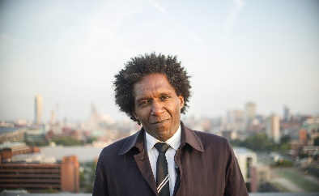
The children have been introduced to their new class role models; Tracey Neville and Lemn Sissay. We have had fun trying our hand at writing some poetry and scoring goals in netball. We hope that Tracey and Lemn’s positivity will help the children build resilience in their learning.

