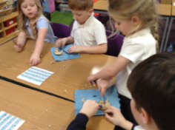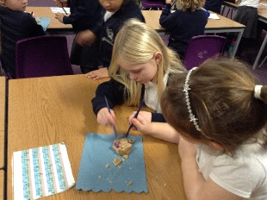

In English, our book has been Never Follow a Dinosaur. The class had been trashed and we followed the footprints to two eggs. After completing a police report, we found out they were dinosaur eggs. We changed the story using other mythical creatures and then we wrote instructions on how to catch the creature. We even created our own dinosaur dances.

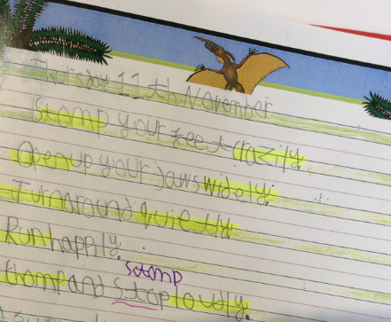

In History, we have been learning about the famous palaeontologist Mary Anning. We have learnt about fossils and had a go at being a palaeontologist and learnt about her life. At the end of the unit, we had a big class quiz with Mr Wood to see how much we knew about Mary Anning.

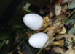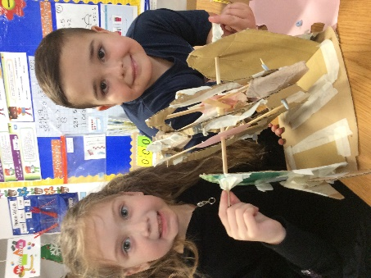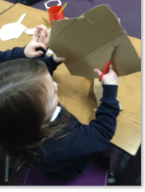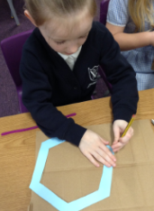

In DT, we have investigated wheels and axles and designed and made our very own Ferris wheel. The children had to draw round templates before cutting them out and putting it all together using different materials. They are very proud of their models and worked well in pairs.

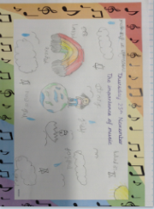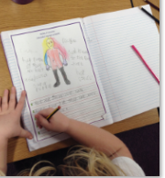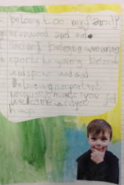

In Science, we have been looking at identifying and classifying animals. We have grouped animals according to their characteristics and used the animal classifications of mammal, reptiles, amphibians etc. We have also learnt about carnivores, herbivores and omnivores using a dinosaur poo experiment.

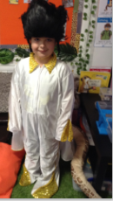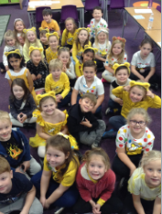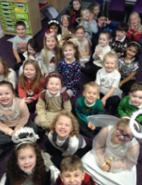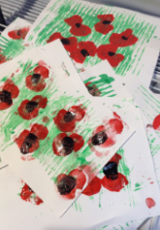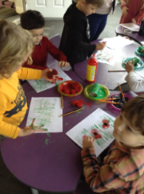

We performed in three Christmas Performances of Humph the Camel which were amazing and we are all so proud of them. At the end of the half term, we have also made lots of Christmas crafts and practised our sewing skills. For the Year 1’s this was a completely new skill.

It has been a busy half term, we have had an author visit, a virtual author visit, made remembrance day art, celebrated Children in Need and had Rockstar day in school.

This was before all the magical Christmas activities that we have really enjoyed together.

In RE, we have had two units this half term, Methodism and Christmas. For the Methodism unit, we had a trip to the local church and Rev.Chris told us a story about John Wesley and we found artefacts and symbols around the church that showed belonging. For the Christmas unit, we answered the question, Why do you think Christians believe Jesus was a gift to the world?