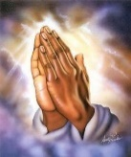

**Maths**

Numbers to 10

Part-Whole within 10

Addition and Subtraction within 10

This term the children will begin exploring number and fluency. They will be exploring the relationships with other numbers, ordering skills and touch upon the important understanding of number bonds.

**History and Geography**

**Non- EU country**

Africa

History and Geography unit

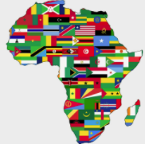

This term the children will be looking at the continents and oceans of the world. They will be comparing Bury to a Kenya in Africa.

**Computing**

How to create a PowerPoint

Children will develop their typing skills and learn to create a power point using Microsoft PowerPoint.

**PE**

Games with PE coach Lewis

Fundamental skills

PE day is Friday



**Science**

**Seasons**

The children will look observe different weathers and seasonal changes.

**Year One Curriculum Map Autumn 1**

**Music**

**Scheme of work – Sing up**

Singing

**RE**

*Jesus’ teachings*

*Kindness- Can you be kind to everyone all of the time?*

**PSHE**

Jigsaw- being me in my world

**English**

**Texts**

Norman the slug with the silly shell- Sue Hendra

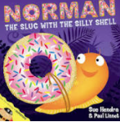

**Genres**

Narrative

Recount

**Art**

Self portraits

Drawing skills- using artist Giuseppe Arcimboldi as inspiration.

